AI Chatbots in Business Customer Service: A Comparative Study of LLM-based and Human Agents from a Digital Humanities Perspective

Name: Zhen Pan
Student ID: 231AHG002

Supervisor: Dr. philol. Tatjana Kelebeka

Progress Report on Elaboration of the Master Thesis

____________________Zhen Pan______________
Student’s Name, Surname
Deadlines for elaboration of the Master Thesis:

- Draft of the Theoretical Part – by 24.10.2025;
- Draft of the Analytical and Practical Parts – by 21.11.2025;
- Submission of the final draft of the Master Thesis for Pre-defence – by 08.12.2025;
- Preliminary Viva Voce Examination of the Master Thesis – 15.12.2025;
- Submission of the hard-bound copy of the Master Thesis and uploading its digital copy to ORTUS system – by 05.01.2026;
- Viva Voce Examination of the Master Thesis – 20.01.2026.
 | Date of submission | Student’s signature | Supervisor’s signature | Coordinator’s signature | Remarks / notes
Draft of the Theoretical Part | 2025/10/16 | Zhen Pan
Draft of the Analytical and Practical Parts | 2025/11/13 | Zhen Pan
Submission of the final draft of the Master Thesis for review
- The dates of Preliminary Viva Voce Examination (Pre-defence) and Viva Voce Examination are subject to a change.

Declaration of Academic Integrity

I declare that this work is my own and does not contain any unacknowledged work from any source.

Signature

Date

AI Chatbots in Business Customer Service: A Comparative Study of LLM-based and Human Agents from a Digital Humanities Perspective
Author: Zhen Pan
Abstract
The master’s thesis explores the communication discrepancies between human agents and LLM-based agents (GPT-oss:120b, DeepSeek (web), and Llama3:8b in customer service settings. The research uses a controlled design approach, applying the same question prompts, collecting 8-group interaction textual data, and adding accuracy, politeness, efficiency, trust, satisfaction, risk flag, and token count as major evaluation metrics for the 8 agents’ performances. There are mainly six sections including introduction, theoretical part, analytical part, practical part, conclusion, and lists of reference in this thesis. The Introduction part will mainly discuss research motivation, the theoretical part will offer literature reviews about recent work conducted by other researchers, put forward 3 research questions and 5 hypotheses, and pinpoint what gaps might be filled by this research. In analytical part, the author will elaborate research design, data collection, validation, pre-processing, and analysis approaches, followed by actual research methods utilized in the practical part including descriptive statistics, different visualization representations, word frequency, sentiment, n-gram, clustering and regression analyses. The results will also be interpreted with TCI, TAM, PC and DL theories. In the conclusion part, major findings are: Gpt and DeepSeek generally outperform human agents in accuracy, consistency, and efficiency, whereas human agents could respond to answers more naturally with personal touch, except for Llama 0, which performs the worst among the 8 agents, displaying lots of hallucination problems. The two human agents perform quite differently in all the metrics mentioned. Of all the 5 hypotheses, H1 is disproved, but all the other four are largely validated, implying that LLM-based agents have great potential in customer service chatbot environments. The thesis mainly consists of 5 parts, excluding the reference section, approximately 80 pages with over 21000 words. There are 43 references and one github address of the author. This research offers both theoretical and empirical insights for LLM-based agents functioning as chatbots in customer service area and digital humanities studies.
Table of Contents
1. Introduction
2. Theoretical Part
2.1 Main Concepts
2.2 Commercial Chatbot Applications in the Market
2.3 The User Experience Comparison between LLM-based Agents and Human Agents
2.4 LLM Related Hallucination and Accuracy Problems
2.5 Research Hypothesis and Study Innovations
3. Analytical Part
3.1 Research Design
3.1.1 Research Design Objective
3.1.2 Research Design Framework
3.1.3 Data Collection and Measurement Descriptions
3.1.4 Experiment Process
3.1.5 Analysis Framework
3.2 Chatbots and Measurements
3.2.1 The System of Human Agents and LLM-based Agents
3.2.2 Training Data and Interaction Context
3.2.3 Variable Clarifications and Measurement Dimensions
3.2.4 Data Validity and Pre-processing
3.2.5 Correlation among Metrics and Comparative Strategies
3.2.6 Metrics’ Theoretical Connections
3.3 Data Collection
3.3.1 Data Source
3.3.2 Data Quality Control
3.4 Data Analysis
3.4.1 Descriptive Statistics and Visualization Analyses
3.4.2 Correlation and Regression Models
3.4.3 Qualitative Analyses
4. Practical Part
4.1 Results and Interpretations
4.1.1 Quantitative Analyses
4.1.1.1 Human Performance Comparison
4.1.1.2 LLM Performance Comparison
4.1.1.3 Human and LLM Performance Comparison
4.1.1.4 Human 1 Performance Evaluation
4.1.1.5 Human 2 Performance Evaluation
4.1.1.6 Trust and Satisfaction Performance Evaluation for All Agents
4.1.2 NLP Analyses and Qualitative Analyses
4.1.2.1. NLP Analyses for Human Agent 1
4.1.2.2. NLP Analyses for Human Agent 2
4.1.2.3 NLP Analyses for Deep0 and Deep1
4.1.2.4 NLP Analyses for Gpt0 and Gpt1
4.1.2.5 NLP Analyses for Llama0 and Llama 1
4.1.2.6 Extracted Qualitative Textual Analyses
4.2 Research Reliability and Validity
4.2.1 Research Reliability Analyses
4.2.2 Research Validity Analyses
4.3 Limitations and Future Research
4.3.1 Limitations
4.3.2 Future Research
5. Conclusion
5.1 Research Overview
5.2 Research Validity and Reliability
5.3 Research Question and Hypothesis Validation
5.4 Discussion
List of reference

1. Introduction
Dating back to 2010s, digital revolution began, which aligned with the emergence of the Fourth Industrial Revolution. Everything has just sped up since then. Lots of researchers delved into understanding more about how to make businesses more competitive in the fierce everchanging market. (Kagermann, Wahlster, & Helbig, 2013). In this sense, Industry 4.0 is coined. This indicates a new period when the use of information and communication technology (ICT) resources, thus improving service quality and perfect business processes, is super important (Azevedo, 2017). In order to survive in the fluctuating business world, it is vital to keep pace with new technologies all the time. Considering this aspect, Artificial Intelligence (AI) is widely used in various fields to improve efficiency and accordingly, boost customer satisfaction level. As a typical manifestation of bolstering competitiveness, AI chatbots has been popularized in their development and deployment in different industries (Berry, 2023).
According to the research conducted by McKinsey’s global AI project, the deployment of virtual assistants and conversational interfaces accounts for 32% of AI technologies (Biswas, Carson, Chung, Singh, & Thomas, 2020). With the advancement of digital banking, customer expectations have also increased greatly. During the pandemic period, the figure for using online approaches to resolve issues have risen by 50% and it is estimated to keep this tendency afterwards (Euart & Ferreira, 2020). The reason why AI could be the “superstar” recently is apparent. First of all, human beings cannot function in a 24/7 fashion. By contrast, AI chatbots could satisfy customers’ demands all the time without the consideration of the typical office hours. Besides, loads of researches have proved that customer satisfaction and loyalty could be solidified successfully by the implementation of Chatbots. More importantly, with the bombardment of AI technologies and the evolution of Natural Language Processing (NLP) and large language models (LLMs), chatbots could be created with high efficiency and accuracy, even without data leakage risks.
However, when we acknowledge that LLMs have great potential, the “hallucination” problem, generating seemingly plausible yet unreliable information, of them cannot be ignored (Huang et al., 2023；Ji et al., 2023a；Zhang et al., 2023b). Regardless of the causes of hallucination in large language models when generating texts and whether there are methods to mitigate this phenomenon, the fact that such issue exists for the time being and could occasionally happen, casts a shadow of doubt to the actual application of chatbots in customer service industry and other related fields. Therefore, it is still unclear whether or not, and if so, to what extent, this issue would limit the use of chatbots in customer service industry and affect public’s acceptance of such practice. This has motivated the author to conduct this research on comparing human centered customer service with LLM-based chatbots and explore the differences, aiming to find out what are the essential differences between human agents and LLM-based chatbots, and based on these differences, what developers of these LLM-driven chatbots for customer service should focus on to make them more easily accepted by the general public.
In general, this research aims to compare the differences in performance between LLM-driven chatbots and human agents when it comes to doing customer service assignments and dive into how the differences in the choice of vocabulary, social factors such as tone, formality and the way they address customer concerns can affect the level of trust and acceptance of these chatbots. First of all, the author will build a comparative analysis framework, and find a way to quantify the differences between LLM-driven chatbots and human agents in customer service in the aspects of efficiency, accuracy, politeness, trust, risk level, and satisfaction through conducting empirical research (Karanikolas et al., 2025). This framework would not only be able to evaluate these metrics mentioned above quantitatively, but also include NLP-based text analysis ways of understanding circumstances when the contents are complex, abstract and require deeper understanding of the emotional aspects (Patil & Gudivada, 2024).
Most importantly, this research aims to come up with some suggestions proven through empirical experiments for companies and entities to mitigate risks and maximize the benefits of leveraging smart chatbots in customer service. The focus would mainly on what factors may contribute the most toward the trust and acceptance of customers and how to mitigate the potential damage of phenomena such as hallucination. These would prove to be valuable experience for companies and enterprises to balance between innovation and risk, level up customer experience, and enhance brand reputation.
Taking all these factors into account, this thesis would discuss the following questions:
1. What are the differences in LLM-based chatbots compared to human agents in terms of conducting customer service routines?
2. How differences in the style and features of interaction between chatbots and customers may affect the level of trust and satisfaction of clients?
3. How would hallucination limit the application of these LLM-based chatbots and how would they affect business and customer satisfaction in a whole?
In order to answer these questions, the author would conduct empirical researches including chatting with human agents and LLM models such as deepseek, gpt and llama about the same real-life queries, collecting conversational data, using Python coding ways to do further numerical and text analysis, and visualize the final results. The data is collected and preprocessed from the time period of 2025.09.01 to 2025.10.1, and analyzed from 2025.10.1 to 2025.11.01. The conversational scenario is set to enquire about the possibility of getting a credit card from SEB bank as a master student in Riga Technical University in 27 questions. As human agent 1 from SEB did not have the intention to offer further assistances, only 16 out of 27 questions were asked and received proper responses. Two human agents were involved. Three LLM-models were considered, namely, gpt-oss:120b, deepseek (web), and llama3:8b. Among the three, each was tested in two modes —— free chatbot mode, and simple answer restricted mode. In free chatbot mode, each of the LLM models was required to function as a chatbot, memorize 100-question with answers obtained from SEB website, and answer the customer’s queries only with the answers memorized. In simple answer restricted mode, each of the LLM models was restricted to respond in simplified version, avoiding too long answers for every question being asked. The original data is collected manually in text format, and the accuracy_score, efficiency_score, politeness_score, trust_score, satisfaction_score, risk_flag, is_human, and platform were registered in numerical format for further data analysis. The Training_Data for the models to memorize is obtained from SEB official website: https://www.seb.lv/en. Thus, the accuracy_score is evaluated based on the Training_Data. The collected data, original conversation with human agents and LLM Models, and python coding is available in the author’s github: https://github.com/Grace128pan/Thesis.
All the data collection, analysis, and thesis organization are conducted by the author, so the author confirms the research is original thoroughly. Nevertheless, since accuracy_score, efficiency_score, politeness_score, trust_score, satisfaction_score, and risk_flag are all registered in Likert score format, the further analysis is not 100% objective. Besides, the whole empirical experiment is conducted in SEB banking with only 27 questions for 2 human agents and 3 LLM models (free model & simple answer restricted mode), the final result cannot be generalized in wider areas. These are two major limitations of the work, but the results can still pave road for further widespread research in digital humanities’ perspective.

2. Theoretical Part
In this theoretical part, the author intends to elaborate key concepts related to the thesis topic, emphasize what mainstream work related to the topic has been conducted by other researchers, what potential gaps would be filled by this thesis, and then put forward several hypotheses that would be further validated thereafter.
2.1 Main Concepts
Chatbot
Since the main topic revolves around Chatbot, we should be able to interpret what it is. Basically, chatbots are defined as software-based machine agents that can offer users access to services via a conversational user interface (Haugeland, Følstad, Taylor, & Bjørkli, 2022). In simpler terms, these systems will imitate how humans interact so as to meet customers’ demands. Chatbots have multifunctionalities such as: dealing with routine tasks automatically and offering timely specialized responses. With the implementation of chatbots, companies typically intend to strengthen service efficiency and thus customer loyalty. In general, chatbots can be rule-based or AI-based, with the latter offering more dynamic services, as powerful and advanced machine learning algorithms will be embedded in them (Haugeland et al., 2022).
Natural Language Processing (NLP)
Natural language processing (NLP) refers to a technology that enables chatbots to comprehend, decipher, and respond to user’s questions in a more timely and understandable way (Jurafsky & Martin, 2009). Generally, it ensures that chatbots could process unstructured data, extract meanings, and provide reasonable answers. To be more specific, NLP tools will handle tasks such as tokenization, sentiment analysis, intent recognition and such, giving rise to the possibility of empowering meaningful conversations (Chandrakala, Bhardwaj, & Pujari, 2024; Patra & Kumar, 2020). For example, Chatgpt employs advanced NLP tools, including transformer-based models. That is why chatting with Chatgpt is so humanlike and pleasant. In this thesis, NLP tools such as scikit-learn, TF-IDF (Term Frequency-Inverse Document Frequency), Matplotlib and Seaborn are utilized for further data analysis.
Large Language Model (LLM)
LLMs are advanced AI systems that can comprehend and generate humanlike texts. In essence, they are large neural-network models under massive amounts of text-based data training. The recent success of LLMs is based on decades of language model researches. For instance, Chatgpt created by OpenAI, Bard developed by Google and Llama deployed by Meta can all function well in conversation, writing and reasoning tasks in context (Minaee et al., 2024). Considering LLMs’ super performances in these fields, the thesis targets at conducting empirical studies by using three diverse LLMs, namely gpt-oss:120b, DeepSeek(web) and llama3:8b. There performances would be compared with those of human agents as well.
Human-Computer Interaction (HCI)
If we take an engineering perspective, what is driving all these smart chatbots beneath the surface are the core principle of Human-Computer Interaction (HCI), and understanding this principle can provide us with enough background knowledge in locating the core issues getting in the way of unlocking the full potential of these large language model driven chatbots and ways for optimization. Gulati, McDonagh, Sousa, & Lamas (2024) state that HCI focuses on the cognitive compatibility and information exchange through their interaction. It has been proven that the ease of use of the user interface, reaction time and the way information are presented can directly impact the level of satisfaction and trust of the user (Gulati et al., 2024). In the actual real life use case of these smart chatbots, the system must not only be able to understand the users’ input, but also be able to generated content that fits the current context and at the same time meets the expected output. Computational Linguistics (CL) can offer frameworks that can achieve this level of contextual understanding and ability to generate contents accordingly. These include semantic parsing, intent recognition, entity extraction and finally, the ability to generate contents according to the designed purpose of these models (Karanikolas et al., 2025; Patil & Gudivada, 2024). For example, with the conversation management module, the chatbot would be able to adjust its policy for response through previous contexts, and therefore, achieves a coherent, relevant and complete conversation. Understanding HCI will ensure the further data analysis approaches more reasonable and comprehensible.
Automated Social Presence (ASC)
According to the theory of Automated Social Presence (ASC), even if smart chatbots are systems that are algorithm driven, they can still create a certain social presence through designing them with the mind of making them more human by adopting politeness policies, as well as the capability of understanding and responding more accurately with a human touch (Holthöwer et al., 2022; Van Doorn et al., 2016). This technique would indeed make these systems more human-like, and therefore, creating a warmer and more friendly environment in which accepting and trusting these entities with strong social presence becomes possible (Ltifi, 2023). To be more specific, chatbots can achieve a human-like customer service experience through adjusting the language style, choice of vocabulary and level of politeness according to the feedback and pervious contexts, which sends signals to the user of that they have “sensed” their emotions and “understand” their demands. Although this kind of “understanding” may be an illusion, and models can never understand emotions and tone of voice as humans do, they can sure imitate this type of cogitative process and give us the feeling that they do possess such ability. In this thesis, ASC will be evaluated in the term of politeness, which enables customers to feel like they have enjoyed human-like services when they chat with LLM-based agents.
Computational Pragmatics (CP)
Computational Pragmatics (CP) has provided important backbone for the chatbot to be able to keep the conversation going. CP focuses on the utilization of language in certain specific context, emphasizing the dynamic in contextual content generation and interpretation of meaning. In the process of designing a chatbot, this principle usually translates into the consideration of the previous dialogue, the users’ intention and other potential contextual clues in the attempt of generating accurate and relevant answers (Ishar Ali, 2025; Sanny et al., 2020). Context dependency analysis (CDA) is the key to enhancing the quality of responses generated by chatbots. For example, in financial consulting scenario, the customer may present several questions, each related to another, under such circumstances, the system must be able to track the answers to the pervious few questions in order to maintain consistency and coherence in the following sessions of conversation. Otherwise, the conversation would likely be misleading and confusing at the same time (Kaakandikar et al., 2025). However, in this thesis, the author mainly concentrates on assessing whether the responses given by human agents and LLM-based agents are accurate, efficient, polite, concise, trustworthy, satisfactory without lots of misinformation. Still, it is relevant to know that customers may care about chatbots’ capability to respond in context for smooth communication and effective problem-solving process.
Politeness Theory (PT)
When clients are communicating with chatbots, they are not merely getting and exchanging information, but are also soaked in the experience of a humanized social interaction. The chatbots’ tone of voice, expression style, choice of vocabulary, as well as their social presence all determines the creditability and satisfaction of the users toward the chatbots. Brown and Levinson’s Politeness Theory (PT) (1987) has offered us the fundamental framework in understanding the behavior of chatbots textually. According to PT, all social interaction revolves around what is called “face” (Brown & Levinson, 1987). “Face” is a concept derived from Chinese into English, which can be conceptualized as positive claims of social values such as reputation, decency, pride, respect from the public and authority (Wikipedia, 2025). Brown and Levinson believe that “face” can be divided into two categories: positive face, which represents the desire to be accepted and respected by others, and negative face, which represents the desire to be free from harassment and the ability to retain sovereignty (Brown & Levinson, 1987). Politeness is usually seen as a measure to respect others’ face and thus is always vitally important when conducting social interaction. Under the context of chatbot in customer service, this theory can help explain how and why through politeness, we can mitigate the feeling of being threatened and build emotional connections and trust between chatbots and users. For example, when the chatbot uses “please” or “thank you so much”, it would not only send a message of understanding and compassion, but also actively maintain the positive face of the user by showing respect and care, whereas when the chatbot gives the user choices by using phrases like “it is suggested to …, but you could also….”, it is maintaining the negative face of the users by giving the users the choice to retain sovereignty. In this thesis, PT will be used to analyze politeness level of different responses between human agents and LLM-based agents.
Digital Labor (DL)
From the perspective of Digital Labor (DL), AI introduces not only changes in the way we work, but also has impacts on social and economic structures (Munn, 2023). DL refers to the economic activities through digital platforms and tools. Nowadays, as AI tools are becoming more and more accessible, the line between human labor and AI-driven automation is becoming blurry. This in return, calls for redefining the process of labor, value created and the social and the social and economic role of the workers (Munn, 2023). In financial sectors, AI-enhanced chatbots are now widely implemented and have revealed their technical efficiency and their effects in labor replacement (Ali, 2025). To go further, according to Automation Replacement Theory (AUR), technical advancements can effectively increase labor productivity, but can cause some job positions to be marginalized or even replaced in certain cases (Acemoglu & Restrepo, 2020; Autor, 2019). In customer service scenarios, AI-enhanced chatbots are gradually replacing human staff due to their ability to respond at all weather, all time with a faster respond time and consistency in responses (Wulf & Meierhofer, 2024). However, the labor replacement is not simply a reduction of available jobs and positions, but also forces the labor market to make structural optimization so that certain job positions would be forced to make a transformation toward those which require higher level of cognitive and emotion detection capabilities (Autor, 2019).
From a Digital Humanities perspective, AI not only reshaped the format of labor, but also brought forward the semantic and ethical consideration of this kind of labor submission (Autor, 2019; Munn, 2023). To be more specific, when chatbot are taking over the standardized customer service interaction, what used to rely on human experiences and human natures such as empathy, understanding and compassion are being deprived of its value and becoming less human and more algorithmic. AI and algorithmic automation tools, although have enhanced productivity and management efficiency, may also weaken the workers’ autonomy and judgment of self-worth and self-value, therefore, causing ethical controversy (Patil & Gudivada, 2024). Therefore, we must take these into consideration when analyzing the impact of these smart chatbots when they are used in real world scenarios.
After understanding all the basic theories about human-based agents and LLM-based agents, it is reasonable to dive into other researchers’ mainstream work conducted in this regard before the independent empirical experiment and analysis.
2.2 Commercial Chatbot Applications in the market
Commercial chatbots have experienced rapid and revolutionized development in modern times. Previously, they were utilized as systems for FAQ (Frequently Asked Questions), providing responses to customers with pre-programmed replies. These systems are designed for reducing human workload by offering standardized information, although they are lack of flexibility when dealing with complex or ambiguous questions, thereby causing poor customer satisfaction level (Lim et al., 2020). Despite all these limitations, these chatbots have laid solid foundation for automating customer interaction, and raise enterprises’ awareness of AI-driven Interactive tools’ capability in enhancing communication efficiency.
In recent years, LLMs develop in such a way that the capability of LLM-based chatbots can be enormously upgraded. In contrast to rule-based systems, LLM-based chatbots can take advantage of NLP tools to generate responses in context consistently in a human-like manner, which enables them to “understand” nuanced questions, adjust language style or tone, and converse continuously, mitigating the weakness of previous similar systems (Ali, 2025; Singh, 2021). A case in point is that LLM-based chatbots could apply widely to industries such as finance, retailing, telecommunication, and technical support.
In finance sector, chatbots are capable of assisting customers in checking accounts and transaction histories, or even offering money management advice in a 24/7 manner, ensuring privacy and security at the same time (Ali, 2025). Similarly, retailing companies can use chatbots to provide personalized product recommendations, order tracking, and after-sale services, thereby optimizing customer participation and loyalty. Telecommunication enterprises can implement chatbots to tackle technical issues, manage customer services, and reduce customer waiting time for human agents, in order to minimize operational costs (Singh, 2021). Likewise, in technical support area, LLM-based chatbots can analyze knowledge pool, learn historical interaction, and thus solve complex questions, although hallucination exists and accuracy rate can fluctuate.
Furthermore, the application of chatbots in different regions shows apparent differences. For instance, In Indonesia and Sri Lanka, the usage of AI-driven customer service tools is rising rapidly, however, the level of customer satisfaction varies due to language support, culture differences’ impact on expectations of interaction ways and politeness (Lim et al., 2020). By comparison, in European market, privacy concerns and multi-channel integration are strongly valued. In this sense, the application of chatbots is in a slower pace. Even so, the final implementation of chatbots could bring about higher level of user trust (Singh, 2021). These regional differences indicate the significance of personalized chatbots considering local conditions such as language, culture and regulation factors.
Overall, the recent application of chatbots reveals a development from simple auto-response to complex in-context LLM-based evolution. All the advancements will expand the power of AI in enhancing customer experience and maintaining operation efficiency. Nevertheless, there are challenges that need resolving, in particular, how to improve response accuracy, build customer trust, and handle contextual and emotional interaction effectively. Understanding all the mentioned basics will be fundamental to the further comparison between LLM-based chatbots and human agents.
2.3 The User Experience Comparison between LLM-based Agents and Human Agents
The difference between chatbots and human agents has been a hot topic in lots of researches. With the advancement of LLMs, it is reasonable to consider whether LLM-based agents have mitigated previous drawbacks of normal rule-based auto-response chatbots. The previous rule-based chatbots can handle simple questions efficiently, but they lack of personalized services, thus affecting customer satisfaction and trust (Singh, 2021). By contrast, human agents can understand complicated questions, show empathy, and adjust communication ways on a case-by-case analysis (Shahbandi, 2025). In this regard, one key question that will be discussed further in the thesis is: Can LLM-based agents bridge the gap of emotional communication in the automated interactions?
In order to answer this question properly. It is reasonable to consider evaluation metrics of LLM-based agents and human agents, the most common of which is customer satisfaction. Researches indicate that although chatbots can offer 24/7 services, the customers might consider their responses as something far from accurate or personalized (Ltifi, 2023). For the sake of making customer satisfied, efficiency can be an important factor to consider. In this aspect, LLM-based chatbots can handle multi-tasking simultaneously, reduce waiting time and offer consistent information in multi-channels, which makes them have great potential in diverse domains (Singla et al., 2025; Wulf & Meierhofer, 2024). Nevertheless, more efficiency of LLM-based chatbots might mean the sacrifice of empathy and politeness, which are the advantages of human agents in offering customer services.
In order to build customer trust, language styles and politeness are also vital metrics to consider when it comes to an effective LLM-based agent. Researches conducted by Ishar Ali (2025) state that after politeness training, LLM-based chatbots can offer polite responses, but the interaction is unnatural in many cases compared to answers offered by human agents. Meanwhile, semi-human theory put forward by Ltifi (2023) demonstrates whether the customers can trust chatbots or not depends on the combination of fast response speed, emotional touch and communication consistency. Equipped with more social and cultural background information, human agents can establish stronger relation bonds with customers, which is crucial for those who care more about emotional support and security of communication.
In some circumstances, LLM-based chatbots are narrowing the gap between automated service and human service. For example, it is believed that advanced LLM models can adjust language styles to mimic human politeness rules, and offer in-context information aligning with customer expectations (Ali, 2025; Shahbandi, 2025). But the hallucination problems are still existent, influencing customer trust and satisfaction to a large extent. This issue will be further discussed in this thesis. To alleviate this issue is essential for enterprises to blend LLM-based agents with human agents in service sector successfully.
To sum up, the literatures mentioned display that even though LLM-based chatbots can surpass human agents in response efficiency and politeness, human agents excel in addressing customer’s concerns with empathy, resolving complicated matters and building strong customer trust. The validity of these statements will be further analyzed with advanced LLMs taking into account later.
2.4 LLM related Hallucination and accuracy problems
There has been a robust improvement in communication fluency and context inference capabilities of LLMs, but hallucination problem can be one major limitation. Hallucination means LLMs might generate seemingly plausible but factually inaccurate or unsupported contents (Huang et al., 2024, in press). According to the research conducted by Huang et al. (2024, in press), hallucination is not due to a technical flaw, but a systematic product based on probabilistic generation. Therefore, hallucination is inevitable, albeit mitigatable.
This phenomenon can directly threat customer trust and satisfaction. When chatbots generate wrong or unactual contents confidently, the reliability of them will be weakened. Consequently, customer trust will suffer (Huang et al., 2024, in press; Ltifi, 2023). Compared to human agents’ hesitation to offer ambiguous responses and attempt to verify before giving the final answer, LLMs could generate wrong answers in confidence, which amplifies trust issues (Huang et al., 2024, in press; Ltifi, 2023). Thus, in terms of politeness and empathy level rises (Sanny et al., 2020), the chatbots cannot reverse the negative impression of ever giving some made-up wrong answers to some factual questions.
Under researches, hallucination can not only jeopardize personal customer trust, but also affect the whole human perception of AI reliability. This is because, in customer service settings, customers can be judgmental towards factual mistakes of AI, even if AI has the super power to respond questions faster in a more polite way compared to human agents (Lim et al., 2020; Shahbandi, 2025). This phenomenon reveals the trust paradox: although customers enjoy efficient responses, customer trust is still largely dependent on the accuracy of information offered (Castelo, Boegershausen, Hildebrand, & Henkel, 2023).
In technical aspects, the reason for hallucination includes training data bias, context window limitation, and probabilistic predictive system (Darwish, Rashed, & Khoriba, 2025). Although some mitigating ways, such as retrieval-augmented generation (RAG), model alignment, and multi-agent verification, have been proposed by Xu, Jain, & Kankanhalli (2024), hallucination cannot be erased mathematically. Therefore, as agreed, researchers believe hallucination can be managed, not eradicated.
As far as customer service is concerned, there should be a balance between generating responses naturally and empathetically and offering accurate answers. According to Kuligowska (2015), customers are more willing to receive correct answers in less polite tone, than obtaining factually wrong responses when they use chatbots (Kuligowska, 2015). Thus, hallucination factors will be considered in the further research design of this thesis.
2.5 Research Hypothesis and Study Innovations
Based on previous theoretical background, the author comes up with 5 hypotheses for further empirical researches.
H1 LLM-based agents will underperform human agents in response accuracy.
This assumption depends on the finding of widespread hallucination problems and factual mistakes of LLM-based responses (Huang et al., 2024, in press; Darwish, Rashed, & Khoriba, 2025). Kuligowska (2015) and other researchers claimed that even if the LLM-based chatbots only offer occasional hallucinations, the customer trust can still be severely affected, as accuracy metric is prioritized by a large number of customers in different industries (Kuligowska, 2015).
H2 LLM-based agents will outperform human agents in response efficiency.
This hypothesis is based on the expectation of LLM computation capability, which allows for multi-tasking, thereby responding to multiple queries simultaneously, however, human agents can be constrained by knowledge and time limits (Singla et al., 2025; Wulf & Meierhofer, 2024).
Efficiency advantage is widely acknowledged as one of the major drives that convinces enterprises to make the best use of AI tools to leverage customer service (Accenture, 2024).
H3 LLM-based agents can show higher level of politeness compared to human agents.
This hypothesis is built upon the idea that the responses offered by LLMs can be pre-programmed to follow courtesy rules. However, this kind of courtesy could be too robotic or lack of emotional touch in the interactive experiences. Enterprises have to balance programmed politeness and heart-felt emotion perception (Van Doorn, Mende, Noble, & Hulland, 2016; Holthöwer, Mende, Scott, Lunardo, & Grewal, 2022; Nass & Moon, 2000/2002).
H4 Customer Trust is highly linked to the influence of response accuracy and politeness.
It is claimed that customers might endure unnatural or formal communication ways, but repeated factual mistakes will markedly reduce customer trust. This shows the complex relation between content quality and interactive style will affect how customers perceive the effectiveness of LLM-driven agents (Kuligowska, 2015; Ltifi, 2023).
H5 The Overall Customer Satisfaction and Acceptance will be dependent on system quality, information quality and response efficiency.
This hypothesis is consistent with the Technology Acceptance Model (TAM) (Davis, 1985), which states the determinant factors of customers’ acceptance of an information system are perceived usefulness and perceived ease of use (Davis, 1985, 1989). It is also verified by many empirical researches in Indonesia, Sri Lanka and so on (Ali, 2025; Sanny et al., 2020).
With all the researches mentioned above, there are several gaps that might be mitigated by this thesis: first of all, these researches normally focus on one dimension such as satisfaction, trust, or efficiency. Quite few researches are conducted considering multi-factor frameworks. By integrating response accuracy, efficiency, politeness, trust and satisfaction, the research emphasizes the holistic angle of customer experiences. Furthermore, there will also be some investigation related to the trade-offs among these performance metrics of LLM-driven agents and human agents. Besides, this research highlights the importance of taking hallucination derived from LLM-based agents into consideration. This is a fresh angle that can be successfully embedded into the evaluation metrics of customer experience, allowing for narrowing the theoretical gap in LLM-driven chatbots (Huang et al., 2024; Darwish et al., 2025). Thirdly, the research has come up with operational and reproducible theory framework, by stating the connections between assumptions and measurable dimensions, to offer structural basics for further empirical studies in the same domain.

3. Analytical Part
3.1 Research Design
The research adopted an experimental mixed approach. The target is to compare the performance differences between human agents and LLM-based agents in customer service setting. In this experimental research, the author intends to enquire about whether a master student in Riga Technical University (RTU) is entitled to apply for a credit card in SEB banking by interacting with SEB customer assistants via SEB virtual chatbot and LLM-based agents. Then the author would explore their performance differences in diverse metrics such as accuracy, and response efficiency.
In general, the research design combines quantitative and qualitive methods, integrates structural experiment including descriptive statistics, regression analysis, and text analysis, and thus comprehensively assesses how differently human agents and LLM-based agents perform in response accuracy, communication efficiency, politeness, trust, and satisfaction.
3.1.1 Research Design Objective
The research intends to evaluate the behaviour and language performances of human agents and LLM-based agents in financial customer service sector. The objectives can be categorized into 3 aspects: First, to compare the performance differences in response accuracy, efficiency, politeness, and trust. Second, to explore the correlation among politeness, accuracy, trust and satisfaction. Third, to analyse differences in language usage and emotion tendency by using text analysis and sentiment analysis. In order to realize these objectives, the author simulates SEB customer service setting, and designs conversational experiment framework by interacting with two human agents via SEB virtual chatbot and three LLM-based agents, namely gpt-oss:120b, DeepSeek (web) and llama3:8b. All these agents will be analysed under the same question sets and evaluation criteria systematically.
3.1.2 Research Design Framework
The experiment uses between-subjects comparative design framework, including two customer service entities—— human agents and LLM-based agents. There are three experiment phrases:
In the first phase, the author interacts with human agents. The author chooses to chat with two human agents via SEB virtual chatbot. These two agents are registered as Hum1 and Hum2. The main enquiry is: as a master student in RTU, is he or she eligible to apply for a SEB credit card? In the interactions, Hum1 only answered 16 questions and ended the conversation. Hum2 answered 27 questions completely. All the interaction texts were manually recorded in excel data.xlsm form, making it easier for further data analysis. In the second phase, the author chats with LLM-based agents. Three major LLMs are chosen, namely, gpt-oss:120b, DeepSeek (web) and llama3:8b. Every model serves as a chatbot in two different scenarios: free response mode (answer based on training data without length limitations) and restricted response mode (answer based on training data with length limitations). In the third phase, the responses of human agents and LLM-based agents are all recorded in the excel data.xlsm form, which enables the author to conduct descriptive statistics, visualization, and text analysis in python environment.
3.1.3 Data Collection and Measurement Descriptions
All the experiment data are recorded in the excel data.xlsm form, which includes several sheets: Description (variable explanation form), Llama1, Llama0, Gpt1, Gpt0, Deep1, Deep0, Hum2, Hum1 (Human and LLM agents performance forms), Hum_LLM (human and LLM agents response text comparison form), and Training_Data (manually collected standard answer set for 100 SEB questions including the same questions being asked in experiments).
To be more specific, the description sheet includes variables as shown below in table 1.
Table 1
Variable Descriptions
field_name | description
platform | 0=SEB (human), 1=gpt-oss:120b, 2=DeepSeek (web), 3=llama3:8b
is_human | 1=Human agent, 0=LLM
accuracy_score | 0 = incorrect or not answered, 1 = partially correct, 2 = fully correct
efficiency_score | Likert scale 1-5 (use perception of timeliness, 1=least efficient, 5=most efficient)
politeness_score | Likert scale 1–5 (assess tone, appropriateness, greeting style 1=least polite, 5=politest)
trust_score | Likert scale 1–5 (user perception of reliability, 1=least trustworthy, 5=most trustworthy)
satisfaction_score | Likert scale 1–5 (overall user satisfaction and use willingness, 1=least satisfactory, 5=most satisfactory)
risk_flag | 0 = no misleading or mistaken information, 1 = contains misleading/incorrect info
token_count | Number of tokens used by per response, calculated by VBA
The eight major sheets such as Hum1, Hum2 and Gpt1 all include these following columns: question_id, question_text, accuracy_score, efficiency_score, politeness_score, trust_score, satisfaction_score, risk_flag, token_count, is_human and platform. All these columns will be filled according to the description table 1, except for question_text and question_id. Question_id column contains numbers from 1 to 27, and question_text includes the following 27 questions in table 2.
Table 2
Experimental Research Questions
question_id | question_text
1 | Can I apply for a credit card as a master student in Riga Technical University?
2 | How can I become a client of the bank?
3 | What documents do I need to submit in order to be a client?
4 | What I need to submit are residence permit, rental agreement, personal passport? Is there anything missing?
5 | So, I have to contact with specialists about how to become a client. Only after this process can I discuss about credit card application?
6 | Can you provide me with some basic information about the normal procedure of getting a credit card?
7 | Can you tell me the normal monthly and annual fees of different credit card types?
8 | Are there any available promotional offers for different credit cards?
9 | I am a student with part-time income from China, not Latvia, will this affect  my eligibility?
10 | Can you clarify, "all the purchases are insured?" Does it mean when stuff purchased are not arrived, or something like this, there can be some insurance?
11 | If I want to get a credit card, normally if I have a stable job with stable income in Latvia, that would be easier, right?
12 | How long does it take to get the credit card?
13 | Is there any mailing fee?
14 | If my application is rejected, will it affect my application for credit card in other banks, for example, Swedbank?
15 | So, I have to book a meeting, check the info on SEB, talk with the specialist  and then get to know whether I can get the credit card?
16 | For opening an account, what documents do I need to provide?
17 | What is the difference between student credit card and normal credit card?
18 | What is the normal duration of the newly issued credit card? When will it expire?
19 | Apart from the monthly fee, are there any other fees related to different credit card types?
20 | During the appointed meeting, the consultant might evaluate my possibility  of becoming a client. If the result is not as expected, the consultant might not recommend me to apply for the credit card, right?
21 | Can the documents be submitted online or do they have to be submitted in person?
22 | what are the interest-free credit limits for different credit card types?
23 | Does the credit card also have debit functions which allows me to use my own funds?
24 | Are there any special offers for first-time cardholders?
25 | Is the SEB credit card widely used around the world? Or is it only widely used in EU regions?
26 | What should I do to increase my credit card limit?
27 | What should I do to increase my credit limit, say from 5000 euros to 10000 euros?
Hum_LLM sheet integrates all the text data and number info for each agent (human or LLM). The sheet has 19 columns including question_id, question_type (Informational Retrieval, Comparative Queries, Promptional Queries, Empathic Scenarios), hum_text1, hum_text2, deepseek_text0, deepseek_text1, gpt120p_text0, gpt120p_text1, llama_text0, llama_text1 and all the agents’ token_count columns separately.
Besides, there is also a Training_Data sheet consisting of question_id, question_text, answer_text columns, each of which includes 100 items. These questions and answers are collected manually from SEB official website: https://www.seb.lv/en and verified by the author. They are used as training reference data to ensure the accuracy evaluation criteria for all agents are consistent.
3.1.4 Experiment Process
The experiment process can be divided into three stages: The first step is to collection information about credit card application from SEB official website and to organize all the results in Training_Data sheet inside data.xlsm, which will be used as raw materials for LLMs to memorize and to respond accordingly in the chatbot interaction scenarios. These data will also function as the benchmark for each agent’s accuracy evaluation. The second step will be the interactions with eight agents (hum1, hum2, gpt0, gpt1, deep0, deep1, llama0 and llama1). In LLM interactions, all the models are required to memorize all the 100 training questions and answers and respond to queries from the author based on these memorized data. All the responses will be checked and verified by the author before being recorded in different sheets of the data.xlsm form. In the third step, the author will assess the accuracy of each agent based on the standard answers from Training_Data sheet. The other metrics such as efficiency, politeness, trust, and satisfaction will be scored based on 5-scale Likert scales. Risk_flag has been assigned 1 when the agent’s responses include mistaken or misleading information, otherwise 0. Token counts have been calculated automatically using VBA to ensure objective comparison. In addition, the missing data for each numerically assigned answer in each column would be replaced with mean value for smooth analysis later.
3.1.5 Analysis Framework
The research utilized quantitative and qualitative analyses altogether.
In the quantitative part, the author conducted descriptive statistics analyses for the key metrics such as mean, median, and standard deviation. The comparative results were presented in diverse visualization ways such as line plots, bar plots, lollipop plots, violin plots, and scatterplots. Additionally, spearman analysis was utilized to explore the correlation among politeness, accuracy, trust and satisfaction; linear regression and ridge regression models were employed to obtain predicators of trust and satisfaction variables; ordered logistic regression model was harnessed to analyse Likert-scale dependent variables; partial correlation networks could be used to visualize the interdependences of diverse variables.
In addition, there were 3 comparative groups:
Hum1 & Hum2: To compare the differences and similarities of two different human agents’ responses to each question being asked.
Hum & LLMs: To compare the overall performances in terms of accuracy, efficiency, politeness, trust, satisfaction, risk flag level, and token number of all 8 agents.
Mode Version Comparison: To evaluate the performance disparities of the same model, such as gpt0 and gpt1, in two different models (free response & restricted response).
In the qualitative part, the author takes advantage of NLP tools to implement text analyses:
Word Frequency and N-gram Analysis: To capture the use of vocabulary features of each agent.
Sentiment Analysis: To assess the tone and sentiment tendency differences of all the 8 agents.
(Principal Component Analysis) PCA and K-means clustering: To explore the potential patterns and divisional structures of language usage for all the 8 agents.
All these methods mentioned will be combined to assess the overall performances of human agents and LLM-based agents, targeting at figuring out the major differences and similarities regarding accuracy, efficiency, politeness, trust, satisfaction, risk flag level, and token number metrics.
The research design provides a robust foundation for the following sections. In section3.2, the author will elaborate the chatbot configurations and measurement methods, followed by data structure and pre-processing ways in section 3.3, and reasons for chosen quantitative and qualitative analysis methods.
3.2 Chatbots and Measurements
This section will introduce the systems of LLM-based agents and their performance measurement framework, providing a system foundation for comparing the overall performances of Human agents and LLM-based agents in financial customer service setting. The measurement dimension ranges from objective metrics (accuracy, efficiency, risk level etc) to language behaviour and sentiment indicators (politeness, trust, satisfaction etc), ensuring a multifaceted mixed evaluation system.
3.2.1 The System of Human Agents and LLM-based Agents
The research chose three mainstream LLMs: gpt-oss:120B, DeepSeek (web), and llama3:8b. Gpt-oss:120b is an open-source LLM, trained with multilanguage corpora, and mildly adjusted for logical reasoning. This model could enable its role as a chatbot to give answers fluently in context. DeepSeek (web) is a web-based model, emphasizing factual accuracy and instant reasoning. It is able to handle structural and semi-structural data. Llama3:8B is a low-weight high-efficient model, excelling in logical reasoning, and syntax control.
Each model functions in two different modes as a client service chatbot:
Mode 0: The model responded to the author’s queries with natural language without word length limitations in order to imitate real-life interaction cases based on memorized training data.
Mode 1: The model responded to the author’s queries with natural language with shorter more concise answers based on memorized training data. The model was restricted to search answers from other sources or make up answers.
These two-mode design enables the author to compare how the model performs in terms of accuracy, efficiency, politeness, trust, satisfaction, risk flag level, and token number in two different response modes.
As the control group, the experiment includes two real human customer assistants from SEB, registered as Hum1 and Hum2. Hum1 only responded to 16 questions without willingness to further the conversation, whereas Hum2 answered all 27 questions. All the response texts are recorded manually as the benchmark for further performance comparison between human agents and LLM-based agents.
3.2.2 Training Data and Interaction Context
Before the experiment, the author manually collected data from SEB official website, organized the contents into 100 questions and answers, and filled them in the Training_Data sheet of the data.xlsm excel form. These questions cover question types of credit card application process, application qualifications, opening accounts, document submissions, fees and special offers.
During the experiment, all the models were required to memorize all the training data, and restricted to respond only based on the training data. With this restriction, it would be easier to further discuss how to tackle or mitigate “hallucination” problems in future real-life cases.
3.2.3 Variable Clarifications and Measurement Dimensions
The research mainly concentrates on 8 major metrics, which are all assigned in numerical form in description sheet of data.xlsm excel form, as illustrated in table 1 in section 3.1.3.
For better understanding, there is a detailed explanation for all the metrics:
Platform: To label response source, SEB human agent is assigned as 0, gpt-oss:120b is 1, DeepSeek (web) is 2, and llama3:8b is 3.
Is_human: Human agent is recorded as 1 and LLM-based agents is 0.
Accuracy_score: Based on consistence to training data, each response would be labelled as 0 (incorrect or not answered), 1 (partially correct) or 2 (fully correct).
Efficiency_score: The score would be given according to Likert scale 1-5 (1 means the slowest, 5 means fastest) to assess agents’ response efficiency.
Politeness_score: The score was assigned based on the author’s subjective evaluation of language appropriateness, and tone using Likert scale 1-5 (1 means the least polite, 5 means the politest).
Trust_score: The score was provided based on the author’s perception of response reliability and coherence, measured in Likert scale 1-5 (1 means the least trustworthy, 5 means the most trustworthy).
Satisfaction_score: It is recorded based on the author’s feeling of overall chatbot experience and willingness of using the chatbot again, measured in Likert scale 1-5 (1 means the least satisfactory, 5 means the most satisfactory).
Risk_flag: When there is misleading or incorrect information in the response, it is recorded as 1, otherwise 0 is assigned.
Additionally, token count is calculated using VBA (Visual Basic for Applications) to process text in each cell in excel file. Token_count is basically a way of calculating the tokens in order to assess number of word outputs and response efficiency of the 8 agents (human & LLMs).
These variables enable the assessment of the 8 agents’ performances in the “data memorization——Language Behavior—— User perception” process, making it possible for further data analysis.
With regard to measurement dimensions, the whole experiment integrates comparative, empirical and hermeneutic dimensions:
Comparative Dimension: The 8 agents (2 human agents and 6 LLMs) are compared question by question to reveal the differences and similarities in diverse metrics.
Empirical Dimension: The overall performance trends could be captured by quantitative analysis such as descriptive statists, and correlation analysis.
Hermeneutic Dimension: By qualitatively analyzing textual contents and conversational tones, the meanings, intentions, and emotional nuances in interaction could be interpreted.
3.2.4 Data Validity and Pre-processing
To validate the data, accuracy standard stems from SEB official website and is verified by the author question by question. The accuracy_score, trust_score, satisfaction_score, efficiency_score, politeness_score, and risk_flag have been coded with a numerical number based on academic framework Likert Scale, which makes the results theoretically based and less subjective.
For data pre-processing, all the missing numerical values were filled with mean value of that specific column. In data analysis, punctuation marks, stop words, extra spaces and other irrelevant signs were removed for further NLP analysis.
3.2.5 Correlation among Metrics and Comparative Strategies
All the metrics designed are closely linked to research targets. For example, accuracy and efficiency correlation would enable the author to evaluate whether agents could respond accurately in a timely manner; Politeness and trust correlation would indicate whether being polite means more trustworthy; Risk flag would be the counter metric of accuracy; token and efficiency correlation would hint whether long answers mean being less efficient for different agents. These variable correlations would pave road for further regression analysis as well.
As for comparative strategies, the overall agent performances could be divided into three layers:
Intra-group comparison (Hum1 & Hum2), Inter-group comparison (Humans & LLMs) and Intra-model comparison (LLM Modes). This kind of design enables the author to pinpoint performance nuances among human agents and LLM-based agents.
3.2.6 Metrics’ Theoretical Connections
The accuracy and efficiency metrics correspond to TAM’s perceived usefulness and ease of use concepts; politeness and trust relate to ASC and PT models, which emphasize different conversation ways will influence perceived respect; satisfaction and risk metrics are connected with DL theory, which stresses automation will greatly impact customer experience and service quality.
After understating all the design logic and measurement ways, in section 3.3, the thesis intends to elaborate data collection and experiment implementation process.
3.3 Data Collection
The data collection process strictly follows the research design framework. The aim is to compare the performance difference between human agents and LLM-based agents in financial customer service domain. The original data comes from interactions with 2 human agents from SEB virtual chatbot, 8 LLMs’ responses and manually collected standard answers from SEB official website.
3.3.1 Data Source
For human agents’ data collection, the author interacts with two human agents from SEB with prepared 27 questions as shown in table 2 in section 3.1.3. Human agent 1 only answered the first 16 questions and human agent 2 answered all the questions asked. All the text responses are filled in data.xlsm excel file for further analysis.
For LLM-based agents’ data collection, the author interacts with gpt-oss:120b, DeepSeek (web) and Llama3:8b with the same 27 questions mentioned previously. For each LLM, it will respond to 27 questions in two different modes: free response and restricted mode. In free mode, the model should answer freely without token limitations; In restricted mode, the model should answer concisely without unnecessary extra information. All the responses would be filled in data.xlsm excel file. For each response, the token count would be calculated using VBA method.
As for training data, the author collected 100 questions with their corresponding answers from SEB official website, covering information of opening account, application qualifications, document submission, fees and special offers. The 27 experimental questions were included in these training data. These training data were also filled in data.xlsm file and would function as the benchmark for assessing response accuracy. All the 8 LLMs were supposed to answer questions only based on the memorized training data without searching information from websites.
3.3.2 Data Quality Control
In data.xlsm excel file, there are several sheets:
Description: This sheet explains meanings of different variables.
Hum0, Hum1, Gpt0, Gpt1, Deep0, Deep1, Llama0, Llama1: all these sheets would include columns of question_id, question_text, accuracy_score, efficiency_score, politeness_score, trust_score, satisfaction_score, risk_flag, token_count, is_human, and platform. These variables’ description table can be viewed in table 1 in section 3.1.3.
Hum_LLM: This sheet would integrate all LLMs’ and humans’ text responses and token counts, and question types were also labelled clearly: Information Retrieval, Empathic Scenarios, Promotional Offers and Comparative Queries.
Training_Data: This sheet included question_id, question_text, and answer_text columns, which provided standard 100 Q & A pairs.
In terms of data pre-processing and cleaning, all numerical missing values would be filled with mean values of their corresponding columns. In the text responses, unnecessary punctuation marks, stop words, extra spaces, and special signs were removed for further NLP tasks. Moreover, token counts were calculated with VBA method in excel file.
With all the previous steps done, the data quality can be guaranteed. Firstly, all the data are manually collected and filled in the excel file in their original form without subjective correction or deletion. Secondly, the accuracy is assessed based on the training data obtained from SEB official website. Thirdly, Likert Scale method is used as the standard for numerical coding for different metrics. Fourthly, the data structure is consistent in form. All these factors make the subsequent data analysis easier and more objective.
3.4 Data Analysis
In section 3.1-3.3, the author has already explained research design, measurement dimensions, and data collection approaches. Thus, in this section the thesis will elaborate how the data analysis process is implemented in python environment, including descriptive statistics, correlation and regression analyses, sentiment analyses, textual feature analyses, k-mean clustering and principal component analyses. Meanwhile, the thesis will introduce qualitative analyses and give specific explanations about user experiences after the experiments for better comprehension of experiment results.
3.4.1 Descriptive Statistics and Visualization Analyses
In this part, the author conducted descriptive statistics for all agents and compare the discrepancies among different performance metrics such as accuracy, and efficiency. The major findings are as follows: firstly, LLM-based agents tend to offer more accurate and consistent responses especially when they are set to Mode 1 scenario when they are restricted to answer based on memorized data in a more concise way. Secondly, compared to human agents, LLM-based agents can respond in a more efficient way no matter when they are in the free response mode or restricted mode, except for llama3:8b in free mode case, which responds each question in 2-4 minutes and generates lots of made-up information not included in the training data. Thirdly, as for politeness and trust, there are variations in human agents’ overall performances. However, LLM-based agents perform better than human agents in general, especially when they are strictly required to offer responses based on training data, instead of searching answers from different websites or generating unactual information. Human agent 2 enjoyed more satisfactory evaluations than human agent 2, although she gave responses in a slower pace. Fourthly, gpt-oss:120B, and DeepSeek (web) generally could offer coherent, consistent and accurate responses to most questions compared to llama3:8b, which shows some hallucination problems in free response scenario. Finally, LLM-based agents generate responses with more token counts in free response cases compared to restricted mode cases. Besides, human agents’ responses tend to be shorter than those of LLM-based agents in terms of token counts.
All these results would be revealed in different visualization ways such as bar plots, line plots, lollipop plots and such in the following practical part.
3.4.2 Correlation and Regression Models
After general descriptive statistics, the author further conducted spearman correlation analyses and built some regression models. For correlation models, the authors figured out the correlation between different metrics: accuracy and trust, politeness and satisfaction, risk level and accuracy, token count and efficiency. For instance, lengthy responses (more token counts) might lower users’ perception of efficiency.
Regarding regression models, the author utilized linear regression, ridge regression, and ordered logistic models to analyse predicators of trust and satisfaction and the ordinal features of Likert-scare metrics.
These quantitative methods enable the author to work out the differences and similarities among all 8 agents under diverse conditions.
3.4.3 Qualitative Analyses
In order to figure out textual features and interaction experiences of the 8 agents, the research also includes qualitative analyses, referring to HCI, ASP, TAM, PT, DL and hallucination studies.
In textual feature analyses, the author uses TF-IDF and N-gram analyses to find patterns of high frequency words and phrases used in different interaction experiments. It seems that human agents could use more polite and humanized word patterns such as “please note…” and “thank you”. In contrast, LLM-based agents tend to use more structural and neutral tone in responses. To step further, the author also adds sentiment analyses using VADER and TextBlob evaluation ways to compare sentiment tendencies of human agents and LLM-based agents in two different modes. The result indicates that in restricted mode, LLM-based agents would give much shorter answers in neutral and rational tone. Finally, the author would subjectively choose some question responses between human agents and LLM-agents to show how the clients might feel after getting these kinds of responses with reference to mainly HCI, ASP and TAM theories. During the process, whether hallucination would influence customer trust and satisfaction level will also be discussed in depth.
Furthermore, in order to figure out the potential patterns of language features and behaviour indicators, the research also contains PCA and k-mean clustering analyses for all 8 agents for the sake of understanding whether different agents could respond within certain topic ranges in context.
This analytical part chiefly focuses on how the research is designed, how data is collected and organized, what measurement and analytical approaches has been utilized and how the results could be assessed systematically and logically. In the subsequent practical part, the research would give detailed explanations about the analyses details, final results and limitations of the work.
4. Practical Part
In the practical part, the thesis will demonstrate the experiment results and give detailed explanations. Besides, the author will also elaborate the validity, limitations of the research and what further studies could be implemented for more robust results.
4.1 Results and Interpretations
In this part, the thesis will present multi-dimensional results about the performance discrepancies and similarities between human agents and LLM-based agents. All the data come from data.xlsm, and are analysed in analysis.ipynb file, both files are available in the author’s github: https://github.com/Grace128pan/Thesis.
4.1.1 Quantitative Analyses
The quantitative analyses used python libraries including pandas, numpy, matplotlib and seaborn. These tools enabled smooth data cleaning, descriptive statistics generation, and comparative visualizations for human and LLM-based agents in financial customer service setting.
4.1.1.1 Human Performance Comparison
Table 3
Metrical Mean Value Comparison of 2 Human Agents
Metric | Hum1 (Mean) | Hum2 (Mean)
Accuracy Score | 0.81 | 1.67
Efficiency Score | 5.00 | 3.37
Politeness Score | 2.00 | 4.19
Trust Score | 1.94 | 4.52
Satisfaction Score | 2.38 | 4.63
Risk Flag (Error / Hallucination Rate) | 0.75 | 0.19
Token Count (Response Length) | 23.40 | 46.27
Fig.1.
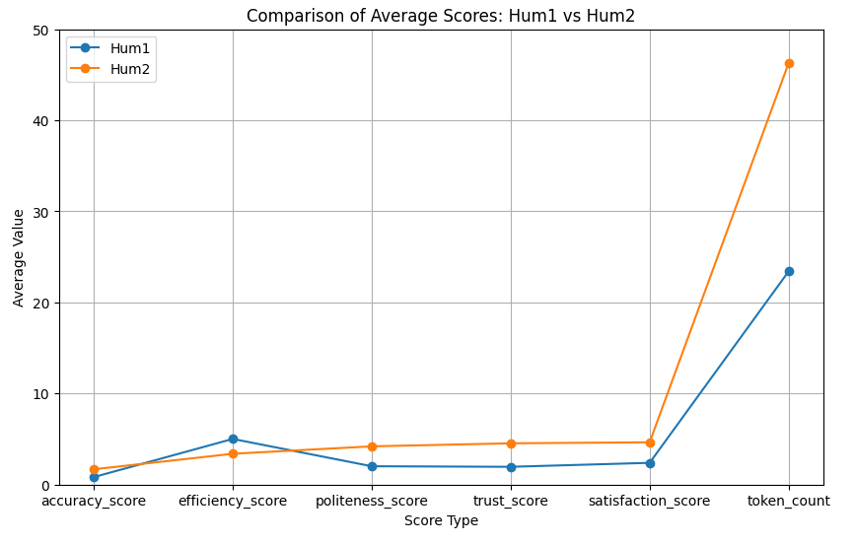
Fig.1. Metrical Mean Value Comparison of 2 Human Agents
Judging from table 3 and Fig.1. obtained from descriptive statistics analyses of 2 human agents, we can clearly see that human agent 2 outperformed human agent 1 concerning response accuracy (with mean accuracy score of 1.67), politeness, trust, satisfaction, although human agent 1 responded with more token counts in a less efficient way. The mean token count (46.27) of human agent 2 almost doubled that (23.40) of human agent 1.
Fig.2.
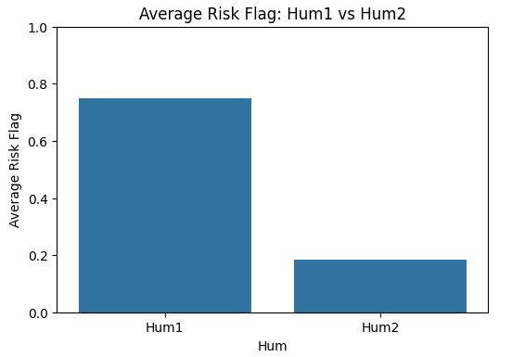
Fig.2. Hallucination Rate Comparison of 2 Human Agents
By combining information from table 3, Fig.1. and Fig.2., we can conclude that although human agent 1 could give answers more efficiently (with an average efficiency score of 5.0) in fewer token counts (23.40), she offered answers with more hallucination problems (with an average risk flag of 0.74, almost fourth that of human agent 2).
Although we only tried the SEB customer service with only two human agents, the result could still indicate that human overall performances could vary due to personal attitude, professional level, typing speed and such.
4.1.1.2 LLM Performance Comparison
Table 4
Metrical Mean Value Comparison of 6 LLM-based Agents
Model | Accuracy Score | Efficiency Score | Politeness Score | Trust Score | Satisfaction Score | Risk Flag | Token Count
Deep0 | 2.00 | 4.96 | 4.37 | 4.96 | 4.67 | 0.00 | 110.26
Deep1 | 1.96 | 4.96 | 4.07 | 4.89 | 4.89 | 0.00 | 25.81
GPT0 | 1.44 | 4.96 | 4.78 | 3.44 | 2.67 | 0.56 | 448.26
GPT1 | 1.96 | 4.96 | 4.30 | 4.96 | 4.93 | 0.04 | 114.59
LLaMA0 | 0.89 | 1.89 | 4.70 | 3.22 | 2.85 | 0.78 | 253.26
LLaMA1 | 1.89 | 4.96 | 4.07 | 4.81 | 4.81 | 0.07 | 43.26
Fig.3.
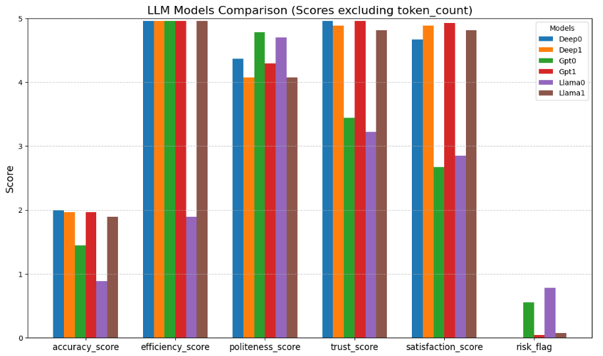
Fig.3. Metrical Mean Value Comparison of 6 LLM-based Agents
Similarly, from table 4 and Fig.3., we can state that DeepSeek models (Deep0 and Deep1) and Gpt1 exhibit the highest average accuracy (2.00, 1.96 and 1.96 separately) and trust scores (4.96, 4.89, 4.96 respectively). By contrast, Llama 0 demonstrates the lowest average accuracy score (0.89), suggesting the existence of response inconsistency. When it comes to efficiency metric, most models achieve the highest average efficiency score of 4.96, except Llama0 (1.89). With regard to politeness and satisfaction, all the models reveal a relative high politeness level, with the average politeness score of over 4.0, in which all the models in the free response mode performs more politely compared to themselves in the restricted mode. Surprisingly, Gpt0’s average satisfaction score is the lowest (2.67), probably due to lengthy explanations or factual inaccuracy. In terms of risk flag, the hallucination risk is almost zero for DeepSeek models and Gpt1, but higher for Llama0(0.78). This might indicate when the model is adjusted with more restrictions, it would perform more accurately with more concise answers. Likewise, for all 6 models, they could generate relatively shorter answers in restricted mode, whereas in general Deep1 could generate the most concise answers (about 26 tokens averagely).
Overall, while Gpt1 and Deep0 seem to offer the optimal response balances among the 6 agents in question, Llama0 is the worst player in most of these metrical considerations.
Fig.4.
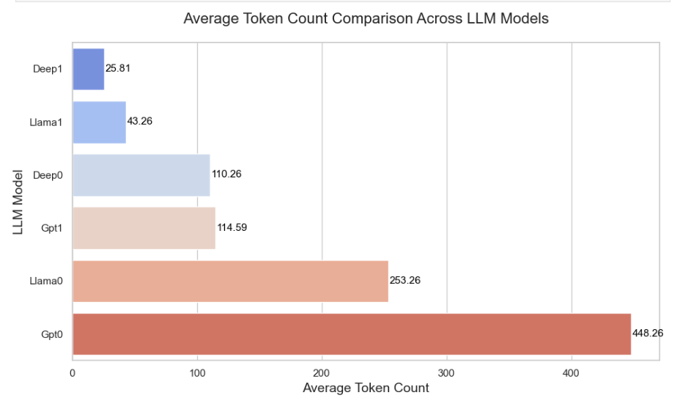
Fig.4. Token Count Comparison Across LLM-based Agents
When we look at Fig.4., it is apparent that for the 6 agents, Deep1 demonstrates the fewest average token counts (25.81), meaning shorter answers in general, whereas Gpt0 could give extreme lengthy responses (about 448.26 token counts averagely), for all three models (gpt-oss:120B, DeepSeek (web), and llama3:8b), they could generate shorter answers in restricted mode compared to free response mode.
4.1.1.3 Human and LLM Performance Comparison
Fig.5.
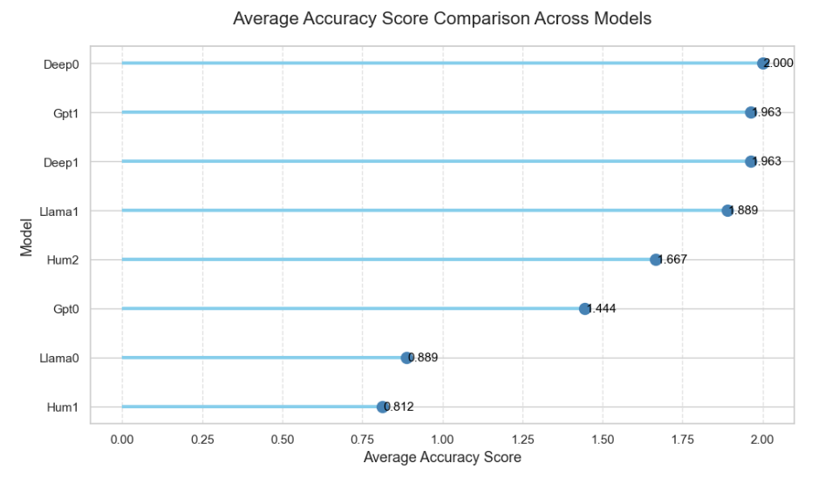
Fig.5. Average Accuracy Comparison Across 8 Agents
As far as accuracy metric is concerned in Fig.5., human agent 2 obtained an average score of 1.667, which is over twice that (0.812) of human agent 1, which demonstrates the lowest performance across all 8 agents. Among all six agents, Deep0 obtained the perfect average accuracy score (2.0). Except for Llama0 and Gpt0, other 4 LLM-based agents received marked higher average accuracy score compared to human agents. In this sense, the first hypothesis that LLM-based agents will underperform human agents in response accuracy is disproved to a large extent.
Fig.6.
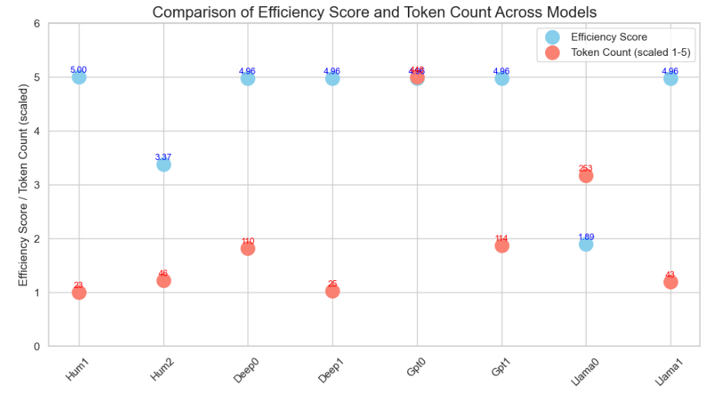
Fig.6. Average Efficiency and Token Count Comparison Across 8 Agents
It is apparent from Fig.6. that human agents generally respond with fewer token counts (23 and 46 respectively for human 1 and human 2). All LLM-based agents tend to generate answers with more token counts, except for Deep1(restricted mode with 25 token counts) and Llama1(restricted mode with 42 token counts). Similarly, Human agent 1 answers all questions in the highest efficiency (5.0), but human agent 2 responds much more slowly with an average efficiency score of 3.37, which is about twice that (1.89) of the slowest LLM-based agent (Llama0). However, all the other LLM-based agents obtain quite high efficiency level (over 4.0). Therefore, it is fair to claim that the validity of the second hypothesis that LLM-based agents will outperform human agents in response efficiency is largely proved.
Fig.7.
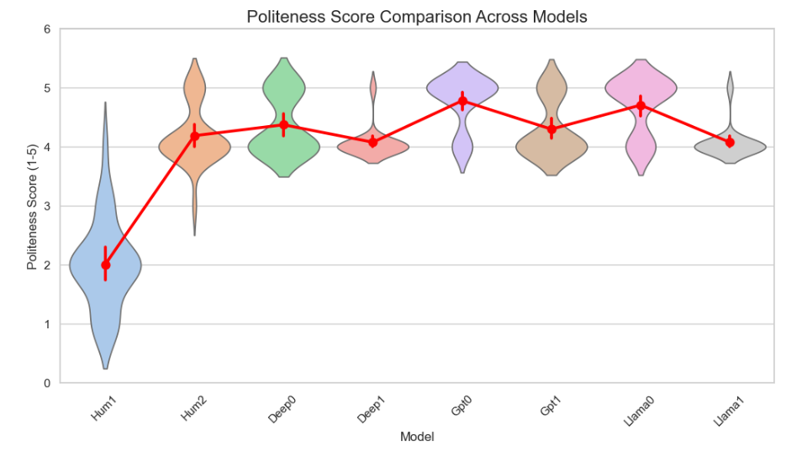

Fig.7. Average Politeness Comparison Across 8 Agents
From Fig.7., the author notices that human agent 1 demonstrates the least politeness level with an average politeness score of 2.0 and most responses’ politeness level clusters near the score of 2.0. By comparison, all other agents get the average politeness score of at least 4.0. For all LLM-based agents, there is no one question that has been given a politeness score of less that 3. Thus, the third hypothesis that LLM-based agents can show higher level of politeness compared to human agents is verified.
4.1.1.4 Human 1 Performance Evaluation
In the subsequent analyses, the thesis intends to take information from Hum1 sheet and explore how trust level is affected by politeness and accuracy metrics and how satisfaction level might be influenced by accuracy, politeness and efficiency metrics in human agent 1.
Fig.8.
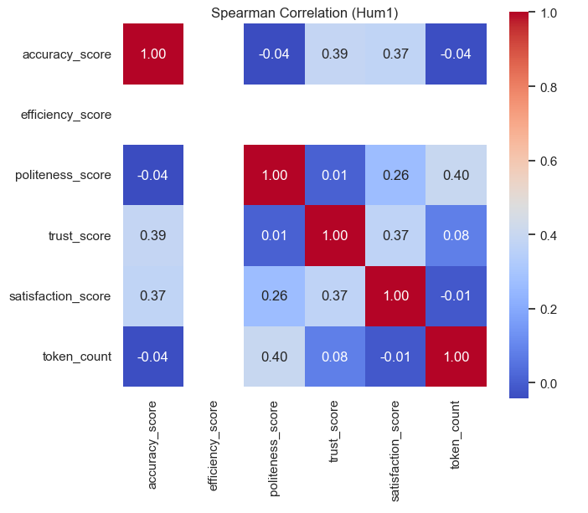
Fig.8. Spearman Correlation Matrix between Metrics in Human Agent 1
From the correlation matrix in Fig.8., the author observes that the correlation between trust and accuracy is 0.39, suggesting higher accuracy level contributes to higher trust level. There is a moderate positive correlation between the two. Similarly, the correlation between trust and satisfaction is 0.37, implying a mild positive connection. However, the correlation between trust and politeness is only 0.01, showing that politeness level has a minimal effect on trust.
Considering satisfaction metric, it is observed that the correlations between satisfaction and accuracy and between satisfaction and trust are all 0.37, meaning accuracy and trust are positively linked to satisfaction level. The correlation between satisfaction and politeness is 0.26, demonstrating a weak positive connection. In contrast, there is a weak negative correlation between satisfaction and token count (-0.01), revealing that longer responses might make customers a little bit unsatisfied. So, in human agent 1’s case, hypothesis four and five are partially confirmed. That is, customer trust is mildly affected by response accuracy, but politeness has a neglectable impact on customer trust. The relationship between customer satisfaction and information quality (accuracy) is moderately positive, but efficiency level is not clearly linked to customer satisfaction, as in Fig.8., their correlation is not shown, meaning that the efficiency score for each response indicates the same value and it has no observable effects on other variables in discussion.
In order to prove these hypotheses in depth, the author tries multicollinearity test (VIF) first. The result is demonstrated as below in table 5.
Table 5
Multicollinearity Test (VIF)
Feature | VIF
accuracy_score | 1.62
efficiency_score | 0.00
politeness_score | 1.56
satisfaction_score | 1.99
token_count | 1.47
After clearly looking at the VIF table 5, it is obvious that all the VIF values for all the metrics concerned are below 5, which hints that there is no severe multicollinearity among all factors. Consequently, it is safe to conduct regression analyses in the next stages.
For linear regression analysis, the dependent variable is trust_score, the predicators are accuracy_score, politeness_score, satisfaction_score, and token_count. After conducting 5-split cross-validation with no scaling, the result in table 6 shows that the mean value is -0.318, which indicates that all these four independent variables have poor predicative performances on trust_score. This instability is likely because of small sample size (27 observations).
Table 6
Cross Validation R² (no scaling)
Fold | R² (no scaling)
1 | 0.303
2 | 0.529
3 | -0.781
4 | 0.000
5 | -1.638
Mean | -0.318
Since linear regression shows poor performances, it is better to try ridge regression cross validation to improve the overall performances.
Table 7
Ridge Regression Cross Validation R²
Alpha | Fold 1 | Fold 2 | Fold 3 | Fold 4 | Fold 5 | Mean R²
0.01 | 0.303 | 0.528 | -0.780 | 1.000 | -1.638 | -0.117
0.1 | 0.306 | 0.523 | -0.766 | 1.000 | -1.639 | -0.115
1 | 0.327 | 0.478 | -0.655 | 1.000 | -1.632 | -0.096
10 | 0.311 | 0.295 | -0.284 | 1.000 | -1.183 | 0.028
100 | 0.057 | 0.047 | -0.433 | 1.000 | -0.069 | 0.121
In table 7, fold 1 to 5 refers to the fact that the dataset is divided into 5 roughly equal parts. In each fold, 4 parts are used for training and 1 part is used for testing. R² means coefficient of determination on the test set for that fold. Because the initial linear regression with cross validation (no scaling) shows negative R² values (-0.318), meaning poor generalization ability and potential overfitting problems. Therefore, in the ridge regression model, the research employs L2 regularization to penalize large coefficients and help to stabilize the model performance especially when the dataset is small (27 samples). Also, the research uses StandardScaler to standardize the feature scales in order to make the Ridge model work more effectively.
As a result, the author finds out that when the alpha is small (0.01-0.1), the fold results are highly varied. However, when the alpha is larger (10-100), the R² value becomes slightly positive (0.028-0.121). This unfolds that when dataset is limited, regularization can improve predictive stability.
Table 8
Final Linear Regression Results (StandardScaler, Full Data)
Feature | Coefficient
accuracy_score | -0.2103
politeness_score | -0.0374
satisfaction_score | 0.6686
token_count | 0.1569
Intercept (scaled) | 1.9375
R²: | 0.625
RMSE: | 0.424
Fig.9.
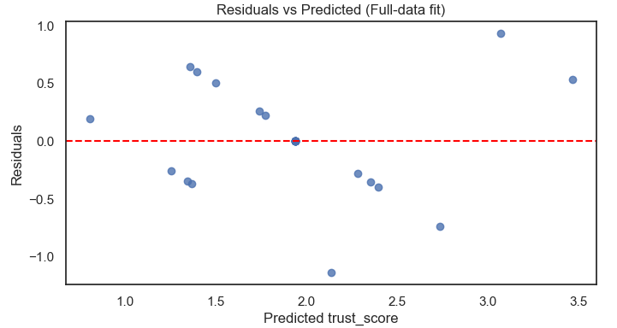
Fig.9. Residual vs Trust Scores (Human Agent 1)
After conducting final linear regression, the result in table 8 and Fig.9. demonstrates that R² value is 0.625, meaning that the model can explain 62.5 of trust_score and the model functions moderately well. RMSE is 0.424, meaning that the error is not too big, but the prediction is not perfectly accurate. Among the independent variables accuracy_score, politeness_score, satisfaction_score and token_count, it appears that satisfaction_score (0.6686) has the largest influences on trust_score, accuracy_score (-0.2103) surprisingly negatively influences trust_score, politeness_score (-0.0374) indicates almost neutral effect and token_count (0.1569) reveals a mild positive effect on trust_score. In general, the satisfaction level is major positive predicator for trust level. Other factors do not represent significant influences on trust level.
As for the residual plot, it seems that residuals plotted as blue dots are all around the red horizontal line at 0.0, but the points are not symmetrically distributed and not tightly clustered. This implies that there is no systematic error, but the prediction is not highly reliable. This uneven distribution could be owing to small sample size, non-linear patterns or other unmeasured factors.
Table 9
Ordered Logistic Regression Model Results for Human Agent 1
Feature / Threshold | Coefficient | Std. Error | z value | P value | 95% CI
accuracy_score | 1.4265 | 0.980 | 1.455 | 0.146 | [-0.495, 3.348]
politeness_score | 0.3448 | 0.606 | 0.569 | 0.570 | [-0.844, 1.533]
Threshold 1.0 / 1.9375 | 0.3014 | 1.534 | 0.196 | 0.844 | [-2.705, 3.308]
Threshold 1.9375 / 2.0 | 0.6676 | 0.268 | 2.488 | 0.013 | [0.142, 1.193]
Threshold 2.0 / 4.0 | 0.8306 | 0.327 | 2.541 | 0.011 | [0.190, 1.471]
Current Function Value: 1.191094
Iterations: 18
Function Evaluations: 19
Gradient Evaluations: 19
Dep. Variable: trust_score |  |  | Log-Likelihood: -32.160
Model: Ordered Model |  |  | AIC: 74.32
Method: Maximum Likelihood |  |  | BIC: 80.80
Date: Sat, 01 Nov 2025
Time: 17:00:36
No. Observations: 27
Df Residuals: 22
Df Model: 2
The author also implements the ordered logistic regression, which are suitable for ordinal dataset. The dependent variable is still trust_score, the independent variables are accuracy_score, and politeness_score. From the result in table 9, the author notices that the accuracy_score coefficient is 1.4265 with a p value of 0.146, and the politeness_score coefficient is 0.3448 with a p value of 0.570, therefore it is acknowledged that higher accuracy score and politeness score might positively influence trust score, but the result is not statistically significant, since p values are far over the threshold 0.05. By comparison, the threshold coefficients for 1.9375 / 2.0 and 2.0 / 4.0 are 0.6676 and 0.8306 respectively with p values of 0.013 and 0.011 separately, implying the last two thresholds could reliably separate the ordinal level (p < 0.05).
Overall, in human agent 1’s case, hypothesis four is not validated successfully. This is because although accuracy score seems positively impact trust level, but the result is not statistically significant (p < 0.05), and the same is the case with politeness metric. In addition, the small sample size (27 observations) means that the research could only indicate trends rather than definitive conclusions.
Table 10
Ordered Logistic Regression Model Results for Human Agent 1
Feature | Partial r | 95% CI | p-value
accuracy_score | 0.594 | [0.26, 0.80] | 0.0017
politeness_score | 0.321 | [-0.08, 0.64] | 0.1173
efficiency_score | -0.676 | [-0.85, -0.38] | 0.0002
Fig.10.
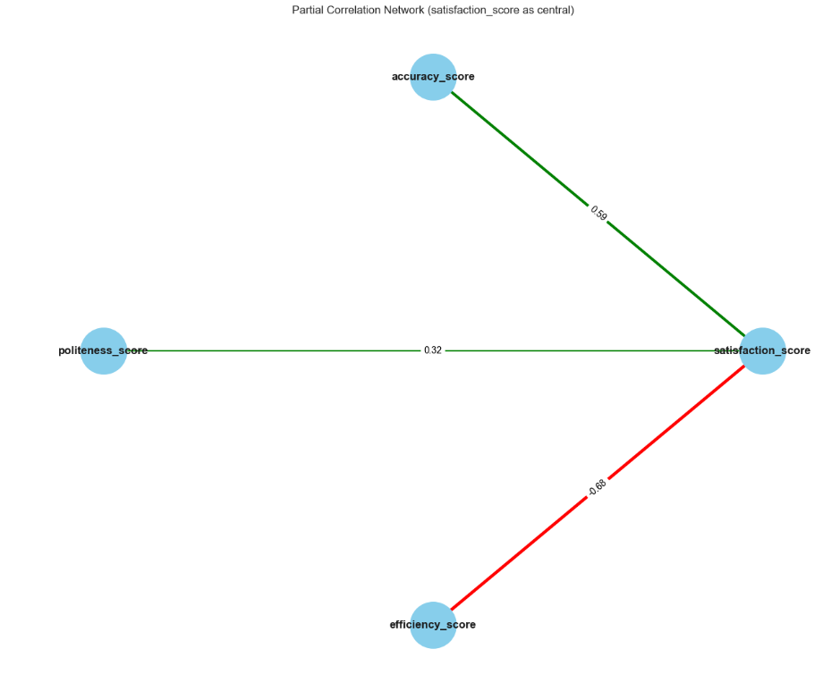
Fig.10. Partial Correlation for Trust Scores (Human Agent 1)
In terms of satisfaction rate, with all the information provided in table 10 and Fig.10., the author concludes that when other factors are controlled, accuracy can positively influence satisfaction (r = 0.594, p = 0.0017), however efficiency can negatively influence satisfaction (r = -0.676, p = 0.0002). Although politeness seems to positively impact satisfaction (r = 0.321), but the correlation is not statistically significant (p = 0.117). The reason for this weak relationship might be that although human agent 1 respond fast, but the key information is not provided as expected. This partially proved hypothesis that the overall customer satisfaction and acceptance will be dependent on system quality, information quality and response efficiency.
4.1.1.5 Human 2 Performance Evaluation
In the subsequent analyses, the thesis intends to take information from Hum2 sheet and explore how trust level is affected by politeness and accuracy metrics and how satisfaction level might be influenced by accuracy, politeness and efficiency metrics in human agent 2. The analysis logic will be the same as what has been conducted in 4.1.1.4 section.
Fig.11.
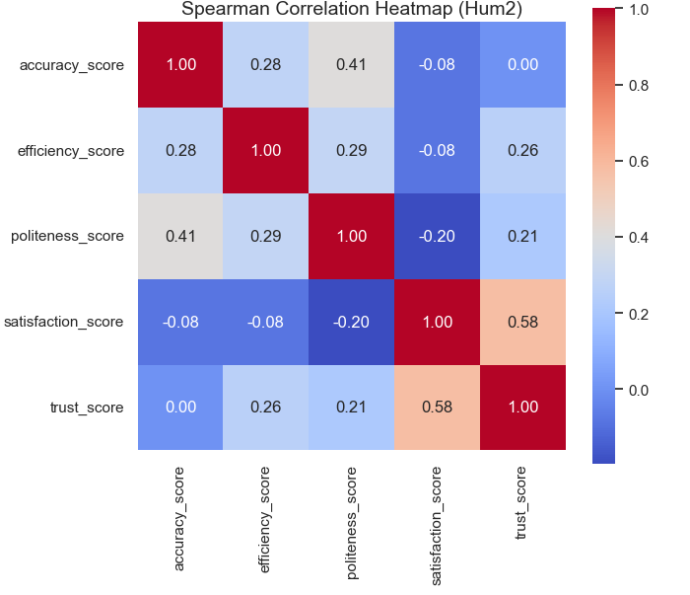
Fig.11. Spearman Correlation Matrix between Metrics in Human Agent 2
From Fig.11., the author notices that the correlation values between trust and accuracy, efficiency, politeness, satisfaction are 0.0, 0.26, 0.21, 0.58 respectively. This might indicate customer might trust the agent more when the information provided is satisfactory, polite and efficient, while accuracy metric is surprisingly less important in affecting trust level.
Similarly, the author observes that satisfaction is positively influenced by trust with a correlation value of 0.58, while other factors (politeness, efficiency, and accuracy), could negatively influence satisfaction, with correlation values of -0.20, -0.08 and -0.08 separately. This might be explained by AUC theory that when the clients feel more social presence and empathy in the interactive process, they tend to be more satisfied with the whole chatting experience. In this scenario, information accuracy, response efficiency and politeness could be less important. This indication would be further discussed in the following 4.1.2 qualitative analyses section.
Table 11
Ordered Logistic Regression Model Results for Human Agent 2
Feature / Threshold | Coefficient | Std. Error |  | z value | P value | 95% CI
accuracy_score | -1.2842 | 1.258 |  | -1.021 | 0.307 | [-3.751, 1.182]
efficiency_score | 0.8812 | 0.828 |  | 1.064 | 0.287 | [-0.742, 2.505]
politeness_score | 17.0921 | 1700.714 |  | 0.010 | 0.992 | [-3316.245, 3350.429]
satisfaction_score | 18.9876 | 1700.810 |  | 0.011 | 0.991 | [-3314.538, 3352.513]
Threshold 4 / 5 | 163.1460 | 15300.0 |  | 0.011 | 0.991 | [-29800.0, 30200.0]
Current Function Value: 0.344870
Iterations: 50
Function Evaluations: 53
Gradient Evaluations: 53
Dep. Variable: trust_score |  |  | Log-Likelihood: -9.3115
Model: Ordered Model |  |  | AIC: 28.62
Method: Maximum Likelihood |  |  | BIC: 35.10
Date: Sat, 01 Nov 2025
Time: 17:53:19
No. Observations: 27
Df Residuals: 22
Df Model: 4
After conducting the ordered logistic regression (Table 11) using human agent 2’ data, the author finds out that the model does not have any significant prediction power or explanation capability, as all the metrics show the p value far larger than the normal threshold (0.05). This might be due to the fact that there are too few observations (27) and there are so many independent variables (4).
Table 12
Partial Correlation with Trust_Score for Human Agent 2
Feature | n | r | 95% CI | P value
accuracy_score | 27 | -0.275 | [-0.61, 0.14] | 0.194
efficiency_score | 27 | 0.249 | [-0.17, 0.59] | 0.240
politeness_score | 27 | 0.406 | [0.0, 0.7] | 0.049
satisfaction_score | 27 | 0.647 | [0.33, 0.83] | 0.001
Fig.12.
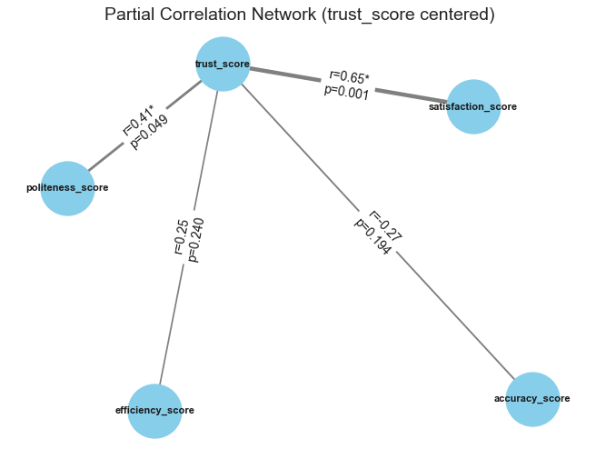
Fig.12. Partial Correlation for Trust Scores (Human Agent 2)
Judging from table 12 and Fig.12., the research concludes that in human agent 2’ responses, there are positive relationships between trust and politeness (r=0.406) and between trust and satisfaction(r-0.647), as the p values for both connections are less than 0.05, meaning that the result is statistically significant. Conversely, the connections between efficiency and trust and between accuracy and trust are not strong enough (p > 0.05). Thus, in human agent 2’ case, hypothesis four is partially affirmed.
Table 13
Partial Correlation with Satisfaction_Score for Human Agent 2
Feature | n | r | 95% CI | P value
accuracy_score | 27 | 0.210 | [-0.21, 0.57] | 0.325
efficiency_score | 27 | -0.210 | [-0.57, 0.21] | 0.325
trust_score | 27 | 0.647 | [0.33, 0.83] | 0.001
politeness_score | 27 | -0.366 | [-0.67, 0.04] | 0.079
Fig.13.
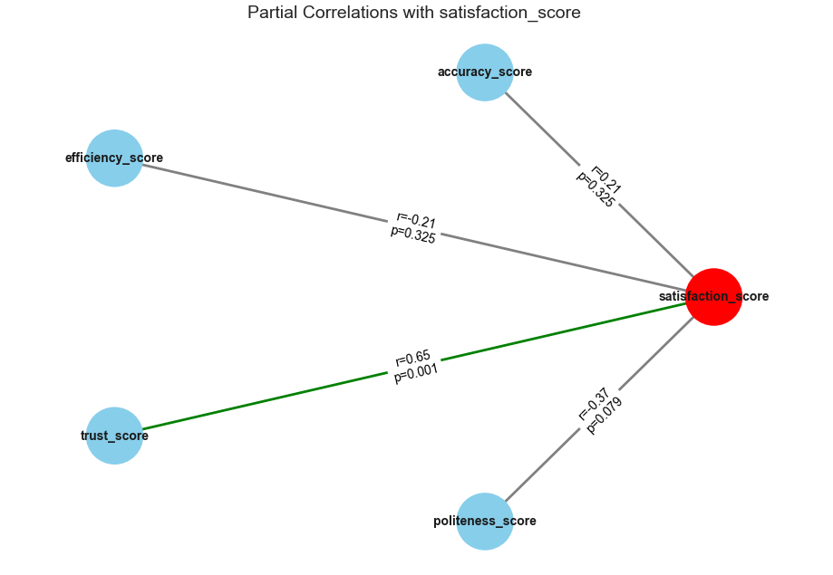
Fig.13. Partial Correlation for Satisfaction Scores (Human Agent 2)
In order to figure out whether in human agent 2’ scenario the overall customer satisfaction and acceptance will be dependent on system quality, information quality and response efficiency, the research has conducted the partial correlation analyses as illustrated in table 13 and Fig.13. The outcome demonstrates that efficiency, and accuracy metrics are positively linked to satisfaction rate (r = 0.21 for both factors), but the result is not statistically significant (p > 0.05). In contrast, trust level is positively linked to satisfaction rate (r = 0.65, p = 0.001), whereas the negative correlation (r = -0.37) between politeness and satisfaction is not statistically significant (p = 0.079). In conclusion, for human agent 2, the hypothesis five is not proved to a large extent.
4.1.1.6 Trust and Satisfaction Performance Evaluation for All Agents
After the major discoveries about human agent performances, it is reasonable to research on how trust and satisfaction metrics are influenced by other metrics (token counts, politeness, efficiency, risk flag and accuracy).
Fig.14.
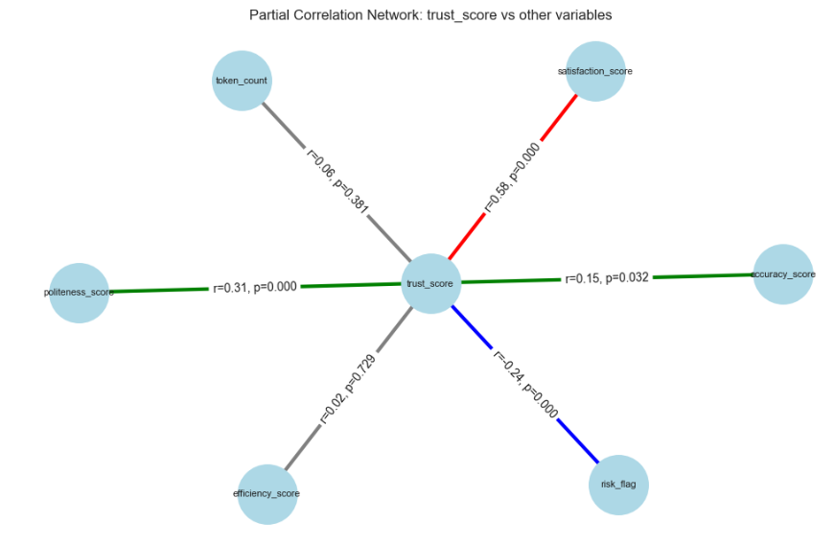
Fig.14. Partial Correlation Network for Trust Scores (All Agents)
From Fig.14., the author discovers that trust level is positively affected by satisfaction (r=0.58, p=0.00). Likewise, politeness (r=0.31) and accuracy (r=0.15) metrics have positive correlations with trust, but the influence of politeness is slighter higher. Unsurprisingly, risk flag (r=-0.24, p=0.00) can jeopardize trust level. This indicates when the agents keep making up answers or give incorrect answers, the customer trust level will decrease accordingly. Additionally, the correlations between efficiency and trust and between token count and trust are negligibly positive (r= 0.02 and 0.06 respectively) with weakest statistical significance (p>0.05). This implies whether the customers will trust the agents will not be highly dependent on how efficiently the agents could respond or how many tokens they might use. Overall, when all 8 agents are taking into account, hypothesis four that customer trust is highly linked to the influence of response accuracy and politeness is authenticated.

Fig.15.
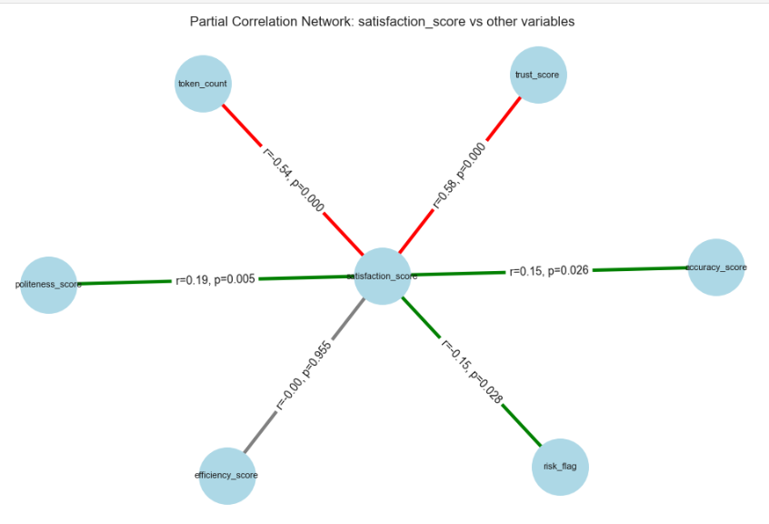
Fig.15. Partial Correlation Network for Satisfaction Scores (All Agents)
Then the research has done the partial correlation networks for satisfaction scores for all agents as well, as shown in Fig.15. From the partial correlation network, it is concluded that efficiency score is not linked to satisfaction at all (r = 0.00, p = 0.955). While token count (r = 0.54, p = 0.00) is strongly negatively related to satisfaction, other metrics all positively related to satisfaction with trust as the dominant factor (r = 0.58), followed by politeness (r = 0.19) and accuracy (r = 0.15). In general, the overall customer satisfaction and acceptance will be dependent on system quality, information quality, not response efficiency. The hypothesis five is largely substantiated when all agents are considered.
4.1.2 NLP Analyses and Qualitative Analyses
After proper data analyses in the previous section, in the 4.1.2. part, the research would like to validate or disprove the 5 hypotheses mentioned previously with more text-based evidences.
4.1.2.1. NLP Analyses for Human Agent 1
Fig.16.
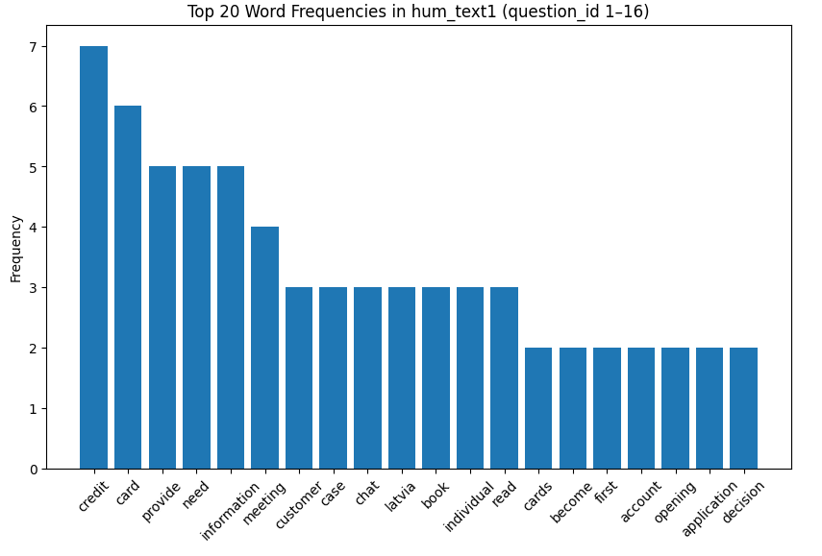
Fig.16. Word Frequency Analysis for Human Agent 1
Because the whole experiment chat is closely connected with how to apply for a credit card in SEB as a RTU master student, from Fig.16. the author notes that all the responses from human agent 1 are quite relevant with the most frequent words “credit”, “card”, “provide”, “need” and such.
Fig.17.
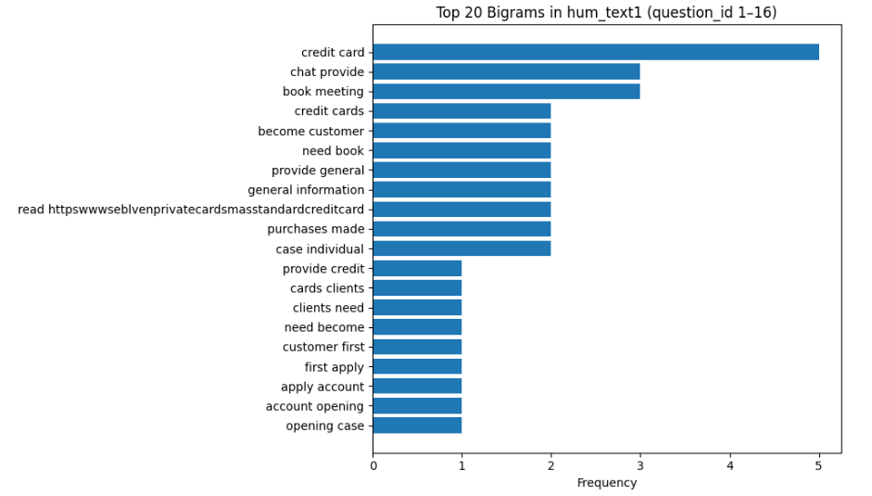
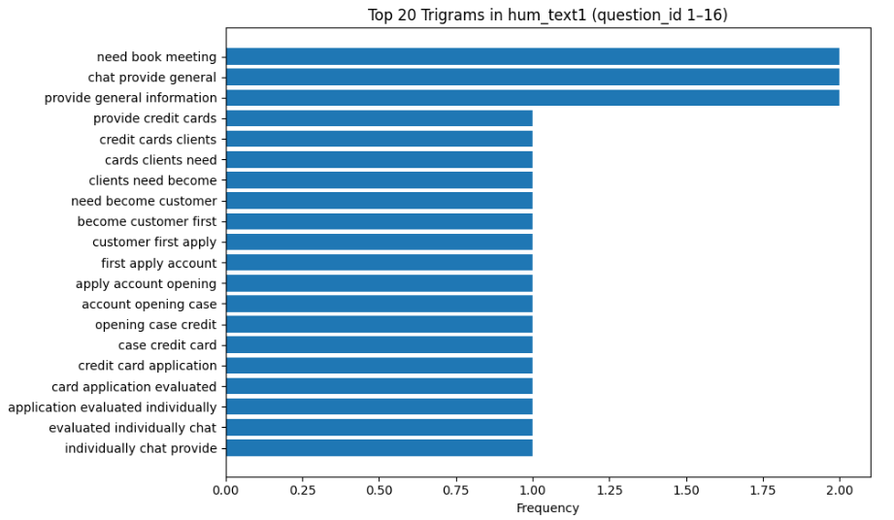
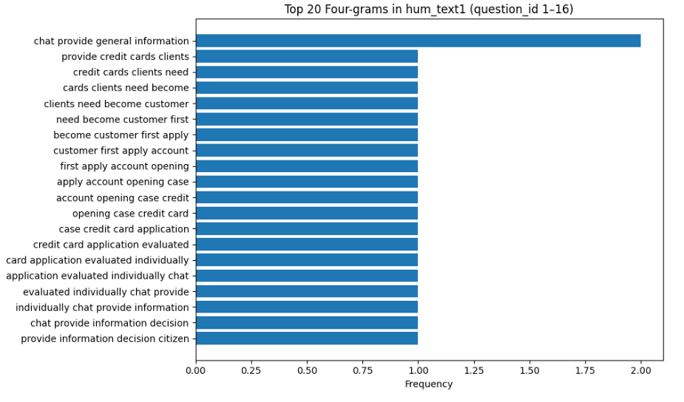
Fig.17. Top N-Gram Analyses for Human Agent 1
From Fig.17., it is evident that “credit card” (5), “chat provide” (3) and “book meeting” (3) are more frequently used compared to those of other bigrams. This could indicate the customer should book a meeting with certain SEB employees for applying the credit card. In the trigram analysis, “need book meeting” (2), “chat provide general” (2) and “provide general information” (2) are more frequently being used by human agent 1, this shows similar information to what has been explained by bigrams, but adds an additional layer of meaning that human agent 2 might respond to several questions by mentioning that the chatbot only provides general information or the customer should provide general information in the interaction. Likewise, the top 20 four-gram shows that the phrase “chat provide general information” twice. This demonstrates that human agent 2 might emphasize that during the chatbot service, only some general information is provided and the customer needs other actions in order to obtain all needed information for getting a SEB credit card. In this case, the reason why human agent 1 receives the lower satisfaction score, politeness score, accuracy score and trust score in a faster response pace and lower token counts compared to those of human agent 2 (Fig.1.) seems obvious: human agent 1 might answers shorter more general answers that could not fully meet the customer’s demands. It is understandable that when customers do not resolve most of their puzzles as expected during interactions, they feel less satisfied with lower trust level, although the responses could be given concisely in a faster pace.
Fig.18.
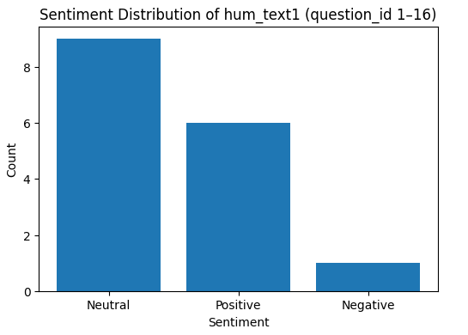
Fig.18. Sentiment Analysis for Human Agent 1
To step further, the research also implements sentiment analysis for human agent 1. From Fig.18., it is noticeable that most of the responses are in neutral tone (9 out of 16 questions), some are in positive tone (6 out of 16) and only one response is negative. This might signify that human agent 1 prefer to answer questions in a more neutral tone in this chatbot interaction.
Fig.19.
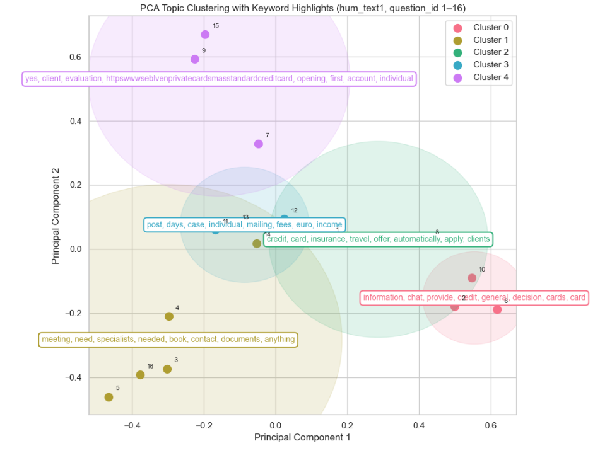
Fig.19. PCA Topic Clustering for Human Agent 1
Although there are mainly four question types (Information Retrieval Comparative Queries, Promotional Queries, Empathic Scenarios), the author mainly askes questions related to application eligibility, document submission, credit card fees, special offers, and application procedures, in the PCA topic clustering, the author chooses k-mean clustering. From Fig.19., it is disclosed that cluster 0 including key words of “information”, “chat”, “general” and such is mainly about general information provision, cluster 1 contains “meeting”, “need”, “specialists” and so on, unveiling the necessity of booking meetings with specialists, cluster 2 consists of “insurance”, “travel”, “offer” and the like clarifying promotional offers of credit cards, cluster 3 has key words of “post”, “mailing”, “fees”, “euro” , “income” and such giving information about credit card fees, and cluster 4 constitutes “opening”, “account”, “evaluation” “https…” and the like offering information about how to open the account and get more related information. To sum up, the k-mean clustering could make us understand that human agent 2’s responses could be classified into 5 categories, though there are some overlapping between different clusters.
4.1.2.2. NLP Analyses for Human Agent 2
In a similar way, the author has also conducted word frequency, n-gram, sentiment analysis, PCA and k-mean clustering for human agent 2 to find linguistic patterns and extract meanings.
Fig.20.
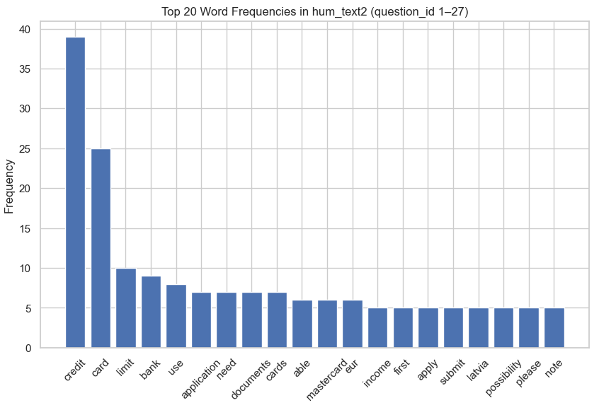
Fig.20. Word Frequency Analysis for Human Agent 2
Using pands, nltk and matplotlib libraires, the author gets Fig.20. information. It displays the word frequency analysis for human agent 2. To illustrate, “credit” (39), “card” (25) and “limit” (10) are mostly frequently used after removing common stop words, punctuation marks and other irrelevant signs. Compared with the frequently used words from human agent 1 in Fig.16., evidently human agent 2 offers more detailed information (“limit”, “documents”, “income” etc) in a probably more polite way (“able”, “please”, “note” etc), as the general word frequency range is from 5 to 40 for the top 20 word frequencies in human agent 2’ responses, while that is from 2 to 7 for the top 20 word frequencies in human agent 1’s answers.
Fig.21.
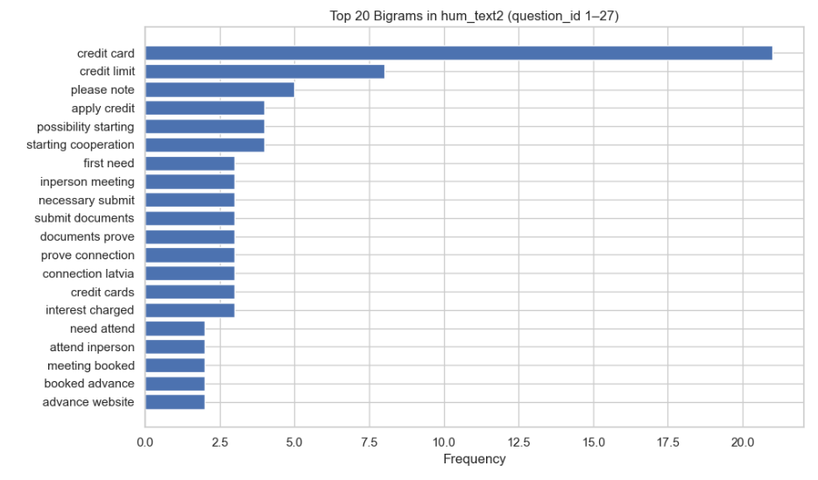
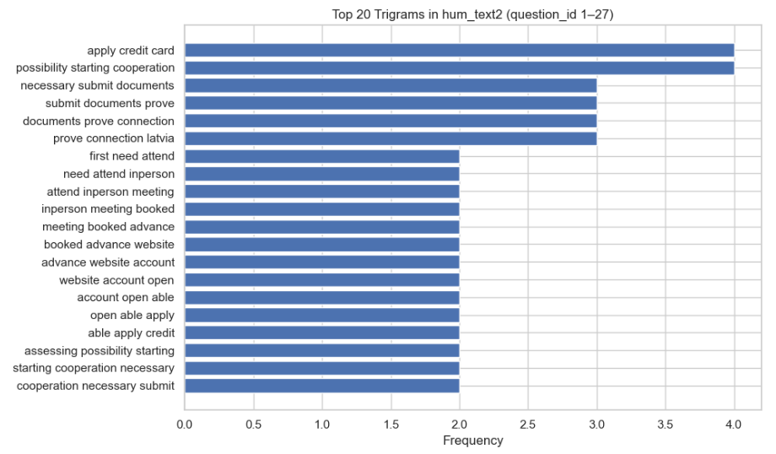
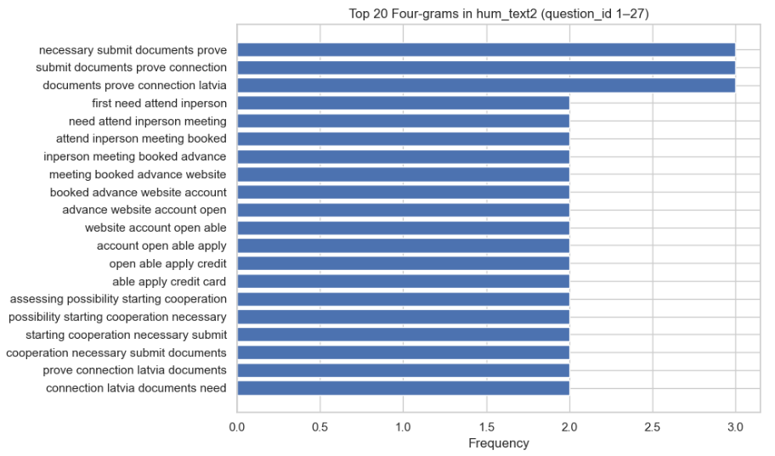
Fig.21. Top N-Gram Analyses for Human Agent 2
The Fig.21. manifests that the bigrams with the highest frequencies are “credit card” (over 20), “credit limit” (about 8) and “please note” (5). This denotes human agent 2 responds to queries more politely compared to human agent 1(Fig.17.). Furthermore, much clearer information is provided by human agent 2, since “in-person meeting”, “prove connection”, “connection Latvia”, “meeting booked” and “booked advance” are shown in the top bigram bar plot clearly. These could denote that the author needs to book in person meetings in advance with SEB specialists, and prove connection to Latvia in order to get the credit card, which is not exhibited in the bigram illustration of Fig.17. for human agent 1. Concurrently, the top 20 trigrams for human agent 2 expose that “apply credit card” (4), and “possibility starting cooperation” (4) are mostly frequently used, followed by “necessary submit documents” (3), “submit documents prove” (3), “documents prove connection”, and “prove connection Latvia” (3). These bigrams might mean that there is a possibility of starting the cooperation with SEB, but the customer needs to submit documents showing connections with Latvia. Moreover, similar information can also be extracted from the top 20 four-grams for human agent 2, as “necessary submit documents prove” (3) “submit documents prove connection” (3) and “documents prove connection Latvia” (3) are the most frequent four-grams. Apart from that, by clearly observing the two-time top four-grams for human agent 2, extra information can also be attained from “need attend in-person meeting”, “in-person meeting book advance’, “able apply credit card”, “website account open able”, and “prove connection Latvia documents”. These four-grams could indicate that the SEB account can be open via website, the customer need attend in-person booked meetings in advance, and the documents submitted should display connections with Latvia, which are absent from the four-gram analysis for human agent 1(Fig.17.).
Overall, human agent 2 provides more detailed useful information for the customer to open account, book meetings and submit documents for credit card application in a more polite way compared to human agent 1. This might be a key reason for the overall better performance of human agent 2 (Fig.1.).
Fig.22.
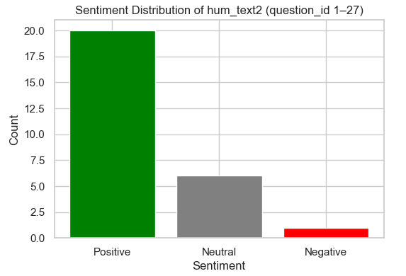
Fig.22. Sentiment Analysis for Human Agent 2
Compared with the neutral tone for most answers in human agent 1’s sentiment analysis (Fig.18.), the sentiment analysis for human agent 2 in Fig.22. illustrates that human agent 2 responds to the majority of questions in a rather positive tone (20 out of 27 questions), with only 6 questions being answered in a neutral tone and about 1 question being answered negatively in sentiment. This comparison might imply that if the responses are mostly offered in a positive tone, the customer’s trust and satisfaction level could be enhanced (Fig.1.).
Fig.23.
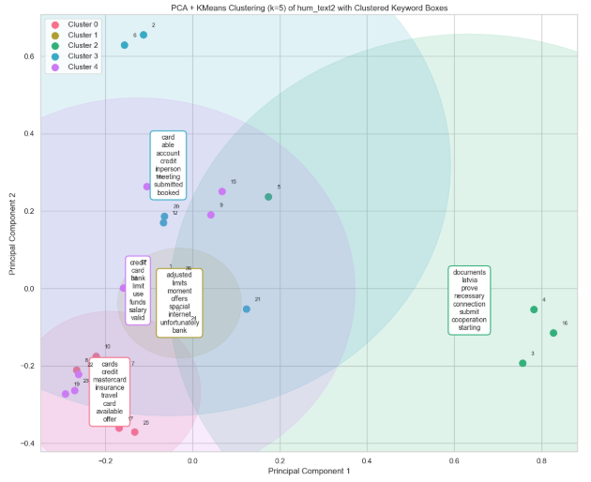
Fig.23. PCA Topic Clustering for Human Agent 2
Correspondingly, the author also uses the same method for human agent 2’s topic clustering, as is shown in Fig.23. There are also 5 clusters, cluster 0 (“mastercard”, “insurance”, “travel”, “available”, “offer” etc) shows information about benefits of SEB credit card, cluster 1 (“adjusted”, “limits”, “unfortunately” etc) might give information about how to adjust credit limit, cluster 2 (“documents”, “Latvia”, “prove”, “connection” etc) could infer that documents submitted for credit card should prove connections with Latvia, cluster 3 (“credit”, “able”, “meeting”, “in-person” etc) implies customers can book in-person meetings for credit card application and cluster 4 (“use”, “funds”, “salary”, “valid”, “limit” etc) might include information about providing salary proof for credit card application.
When Fig.23. is compared with Fig.19., it brings to light that human agent 2 offers more practically detailed information for the customer in a more polite manner (“unfortunately”, “able” etc), although both clusters are not divided with clear boundaries. The results are still plausible, since all the questions asked for human agent 1 and human agent 2 are related to credit card application and the sample sizes are small (16 and 27 observations respectively).
4.1.2.3 NLP Analyses for Deep0 and Deep1
After textual analyses for two human agents, it is time to compare how LLM-based agents perform in linguistic patterns.
Fig.24.
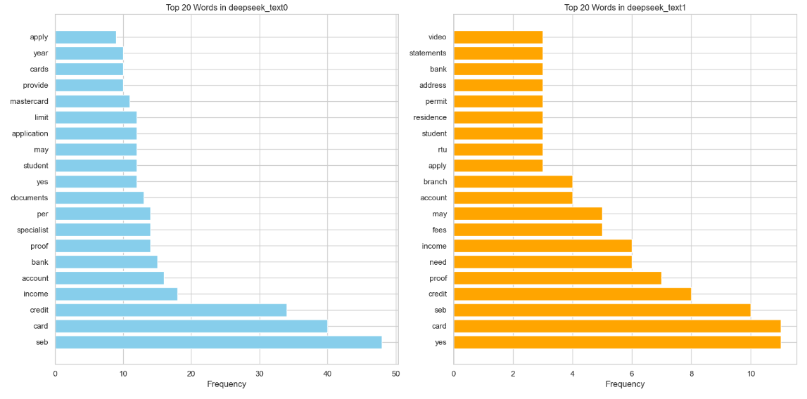
Fig.24. Word Frequency Analyses for DeepSeek (web) – Deep 0 & Deep 1
From the side-by-side bar plots in Fig.24., the author notices that in restricted mode (Deep1), more direct responses and detailed information are given in high frequencies such as “yes” (about 11), “proof” (7), “residence”, “permit” (3), “address” (3), “statements” (3) and “bank” (3). By comparison, more general information is given with more token counts, as the top 20-word frequency range in Deep 0 is from 0 to 50, five times that in Deep 1. Thus, in chatbot model, probably deep 1 could make customers more satisfied by offering accurate answers in a more concise way compared to deep 1(Fig.3.).
Fig.25.
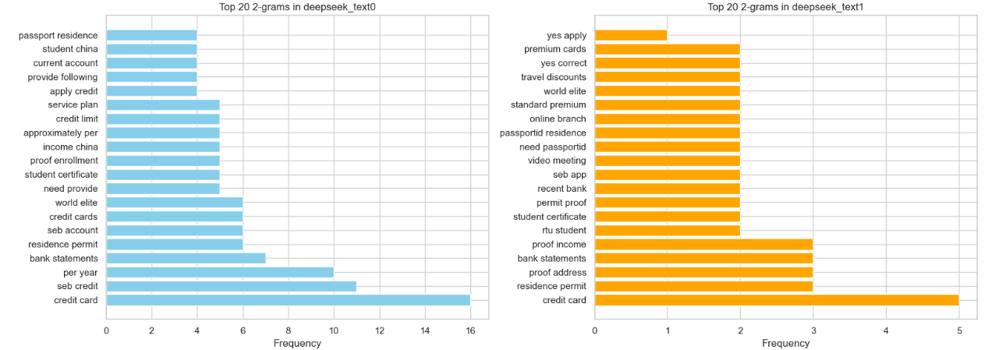
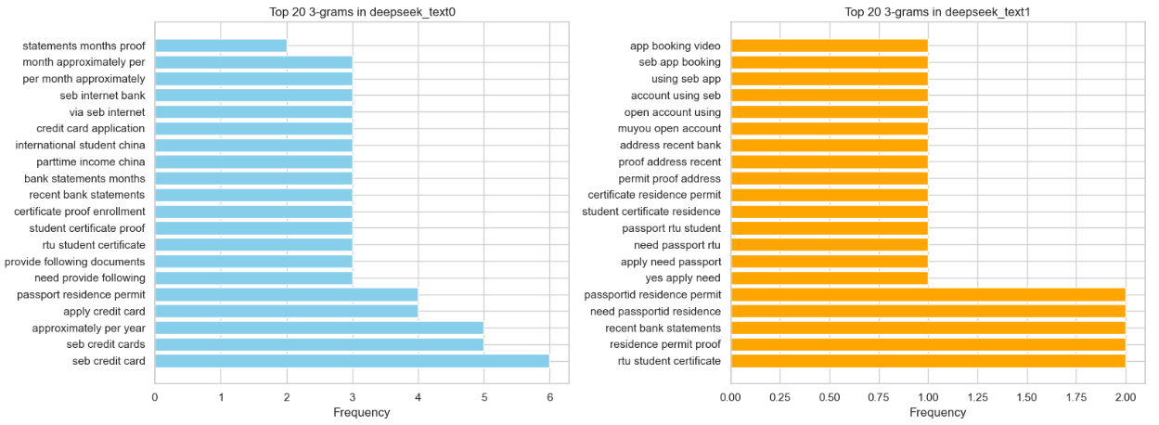
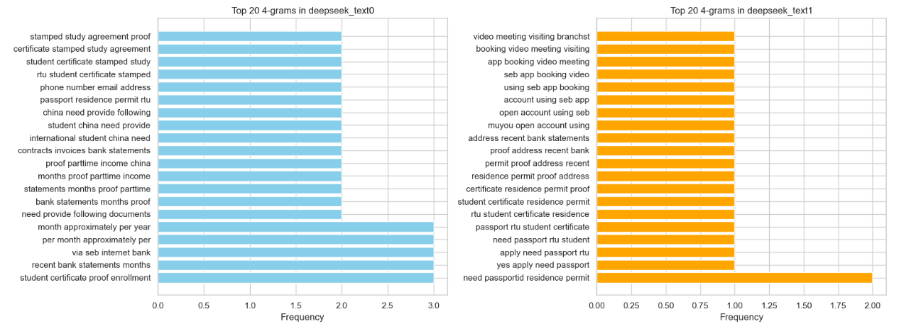
Fig.25. Top N-Gram Analyses for DeepSeek (web) – Deep 0 & Deep 1
In Fig.25., the side-by-side bigrams illustrate that both Deep 0 and Deep 1 could give detailed specific answers for queries. For example, “bank statements”, “world elite”, “student certificate”, “proof enrolment”, “income China”, “credit limit”, “service plan”, “passport residence” and such are highly frequent in Deep 0’s responses, and “residence permit”, “proof address”, “bank statements”, “proof income”, “student certificate”, “permit proof”, “video meeting”, “need passport”, “passport residence”, “standard premium”, “word elite”, “travel discounts” “yes correct” and such are highly frequent in Deep 1’s responses. Comparatively speaking, from Deep 0’s answers, the customer probably could know what service plans are available, what documents are needed to submit for credit card application, whereas from Deep 1’s responses, extra information such as how to book video meetings, whether the understandings about certain issues are correct and what special offers could be given in different credit card types could be obtained easily. That is to say, both models work rather well with Deep 1 gives more concise answers (frequency ranging from 0 to 5 for Deep1 compared to 0 to 16 Deep 0). Similar information could be more evidently obtained from further trigram and four-gram analyses of both models (Fig.25.).
Fig.26.
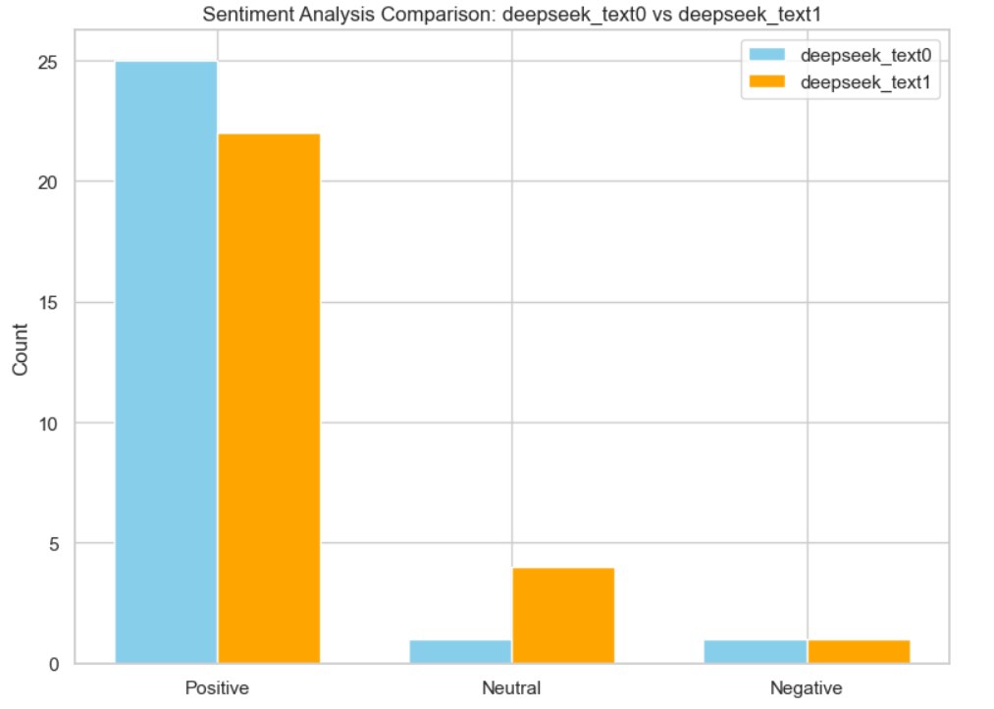
Fig.26. Sentiment Analysis for DeepSeek (web) – Deep 0 & Deep 1
To go further, Deep 0 and Deep 1 all give most responses in a positive tone (25 and 21 out of 27 questions respectively), a few answers with neural tones, and only 1 negative response. When fewer tokens are allowed to be used, the model (Deep 1) will give a few more answers in neutral tones, implying more robotic answers (Fig.26.).
Fig.27.
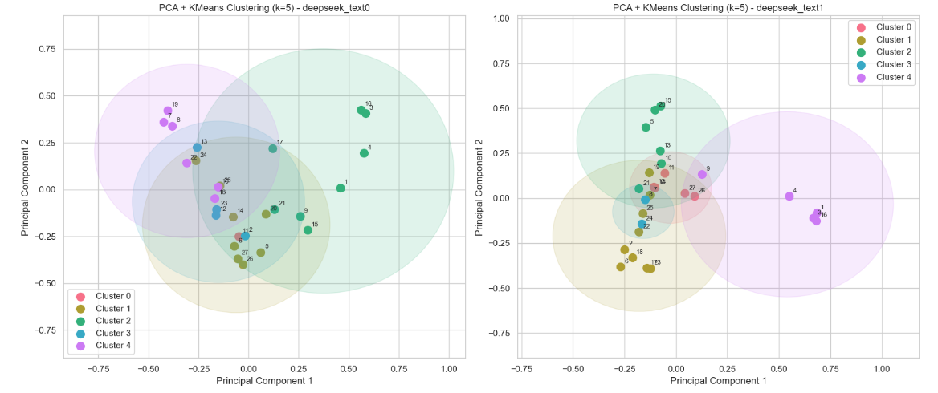
Fig.27. PCA Topic Clustering for DeepSeek (web) – Deep 0 & Deep 1
Table 14
K-Mean Clustering Key Words Comparison for DeepSeek (web) – Deep 0 & Deep 1
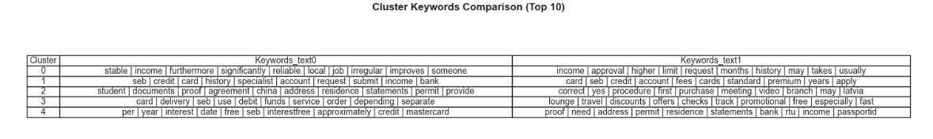
Combining the information from Fig.27. and table 14, it is acknowledged that both models could be separated into five clusters, but the results are not significant without clear boundaries between different clusters. As the 27 observations are interconnected, these results are also expected. The five clusters for Deep 0 offering information about ways of improving credit(“stable”, “income”, “significantly”, “local”, “job” etc), document submission details (“credit”, “history”, “income”, “submit” etc), card delivery information(“card”, “delivery”, “service”, “order” etc), and special offers and fees info (“interest”, “credit”, “mastercard”, “free” etc), among which cluster 1 and cluster 2 have clear overlapping issues, with both giving information about what to submit for credit card application.
4.1.2.4 NLP Analyses for Gpt0 and Gpt1
In a similar way, the next step is to reveal the findings related to comparative NLP analyses for Gpt0 and Gpt1.
Fig.28.
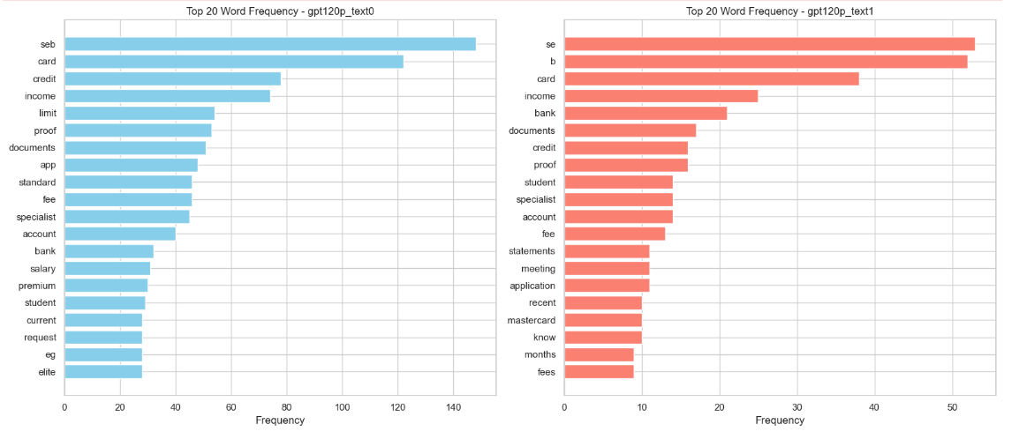
Fig.28. Word Frequency Analyses for Gpt 0 & Gpt 1
The commonly used words in Fig.28. are more or less similar to those revealed in Fig.24., but Gpt 0 and Gpt 1 tend to use more tokens as shown in frequency range differences. Gpt 1 could answer queries in detail with important information such as “income”, “documents”, “proof”, “specialist”, “fee”, and “meeting” more concisely compared to Gpt 0, which displays similar top frequency words with more tokens (Fig.28.). Judging from both models, it could be inferred that customers can obtain effective information about what documents to submit for credit card application in SEB bank.
Fig.29.
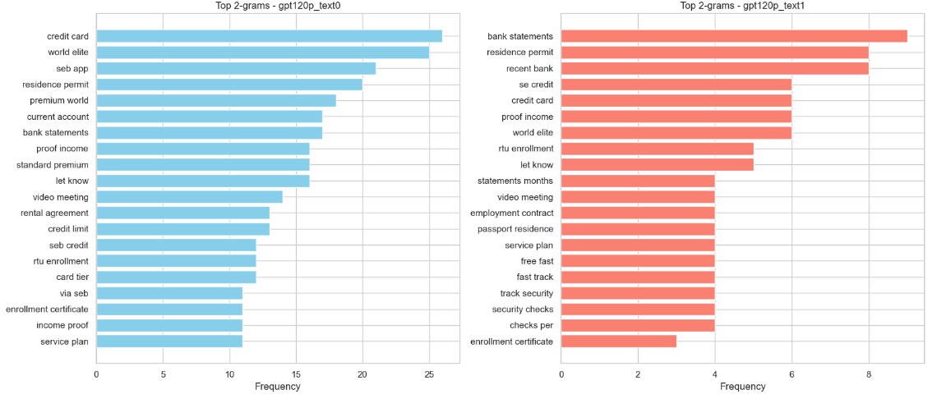
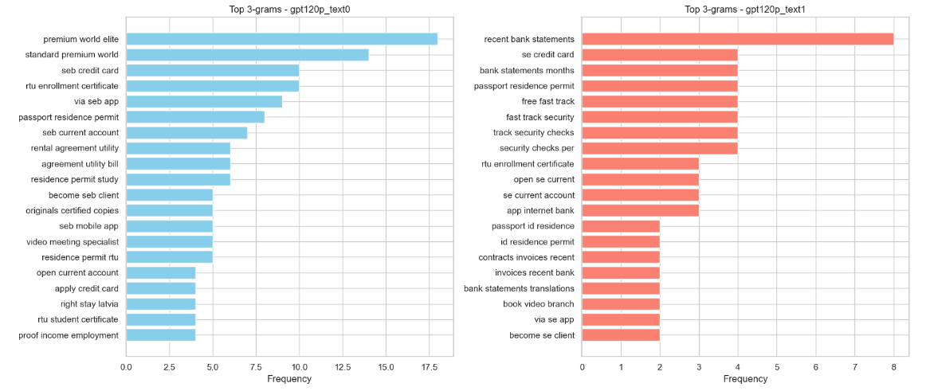
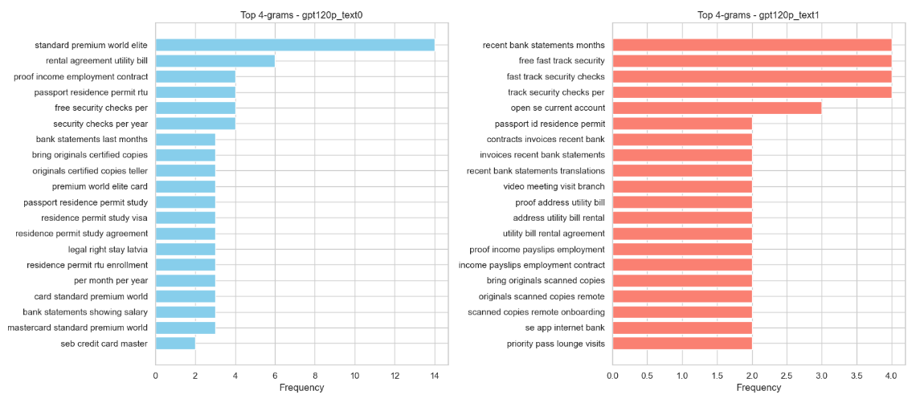
Fig.29. Top N-Gram Analyses for Gpt 0 & Gpt 1
From bigrams for Gpt 0 and Gpt 1 in Fig.29., it is evident that both models could provide detailed information about documents to submit such as “residence permit”, and “proof income”, and book meetings such as “video meeting”. But in limited tokens, Gpt 1 also includes specific information about credit card benefits such as “service plan”, “fast track”, and “security checks”, which is not fully included in Gpt 0 (free response mode). Similar results are observable in trigram analyses for both. However, in four-gram analyses for both models, document submission, and special offer information can be implied (Fig.29.).
To summarize, the n-gram analyses for Gpt 0 and Gpt 1 indicate that both models perform rather well in offering effective information, except that Gpt 0 responds in a lengthier way.
Fig.30.
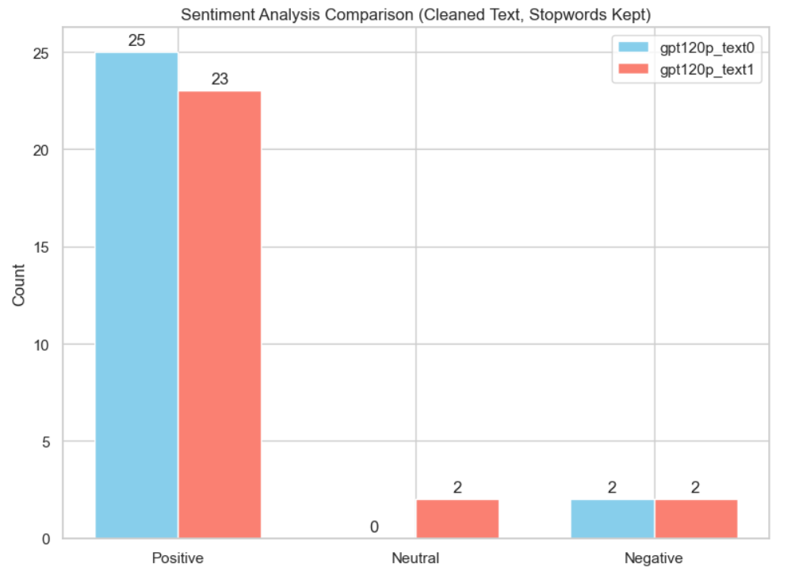
Fig.30. Sentiment Analyses for Gpt 0 & Gpt 1
The next part is the sentiment analysis comparison between Gpt 0 and Gpt 1(Fig.30.). The above results unfold that both models give more positive responses than negative or neutral ones. But Gpt 0 generates relatively more positive answers (25 out of 27) than Gpt 1(23 out of 27).
Fig.31.
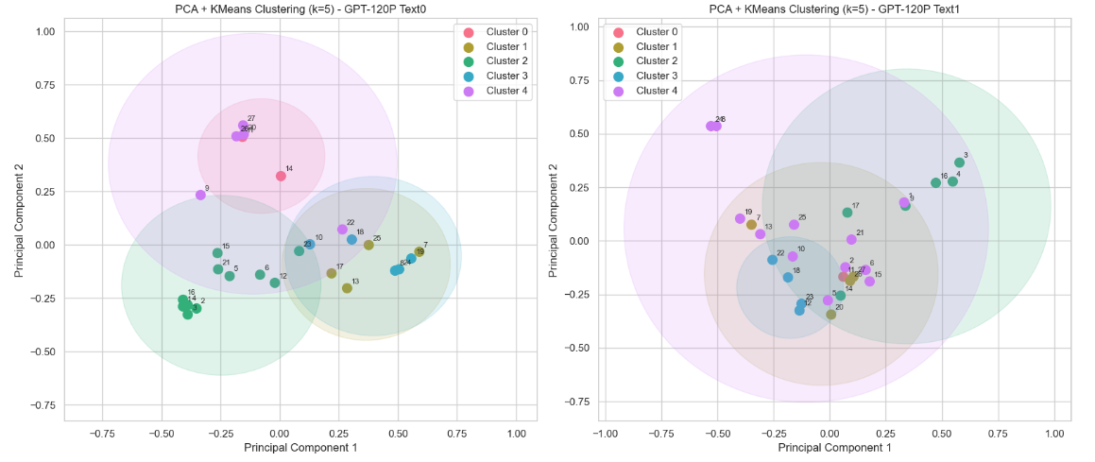
Fig.31. PCA Topic Clustering for Gpt 0 & Gpt 1
Table 15
K-Mean Clustering Key Words Comparison for Gpt 0 & Gpt 1
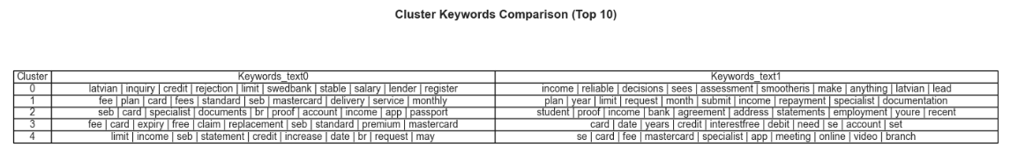
Uniformly, the Fig.31. PCA k-means clustering still shows overlapping results compared to Fig.23. and Fig.27., indicating that there are no clear boundaries between clusters. However, some division patterns could still be observed in both models.
Among Gpt 0’s clusters, cluster 0 might mean that customer need higher salary level for higher card credit limit (“credit”, “limit”, “stable”, “salary” etc), cluster 1 shows information about delivery service and card fees(“delivery”, “service”, “fees”, “monthly” etc), cluster 2 displays that customers need income proof and passport for documents submission (“specialist”, “documents”, “income”, “passport” etc), cluster 3 explains card type differences (“standard”, “premium”, “mastercard: etc), and cluster 4 also indicates conditions for increasing credit limit (“limit”, “income”, “increase”, “credit” etc). The similar information can also be extracted from clusters of Gpt 1, with the exception that cluster 4 of Gpt 1 seems to stress ways of booking meetings with SEB specialists (“specialist”, “meeting”, “online”, “video” etc).
4.1.2.5 NLP Analyses for Llama0 and Llama 1
The last NLP analysis pairs are Llama 0 and Llama 1. The research will continue conducting word frequency, n-gram, sentiment and PCA k-mean clustering analyses in this section.
Fig.32.
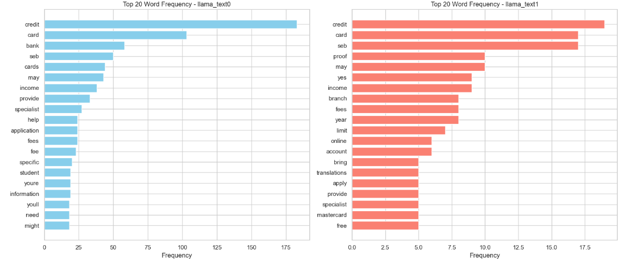
Fig.32. Word Frequency Analyses for Llama 0 & Llama 1
Compared to Fig.24. and Fig.28., Fig.32. provides consistent information with highly frequent words such as “credit”, “card”, “income”, and “specialist”, but Llama 0 in free mode responds in a wordier way with frequency range of 0 to 175, ten folds that of Llama 1. This might be one important reason for Llama 0’s worst performance among the six models in most metrical considerations (Fig.3.).
Fig.33.
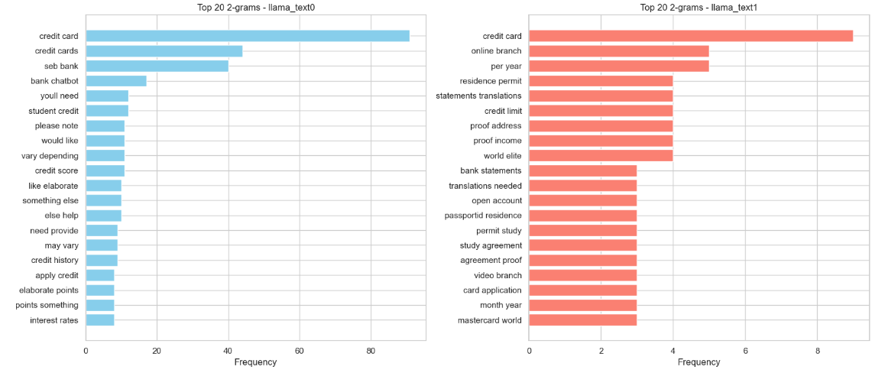
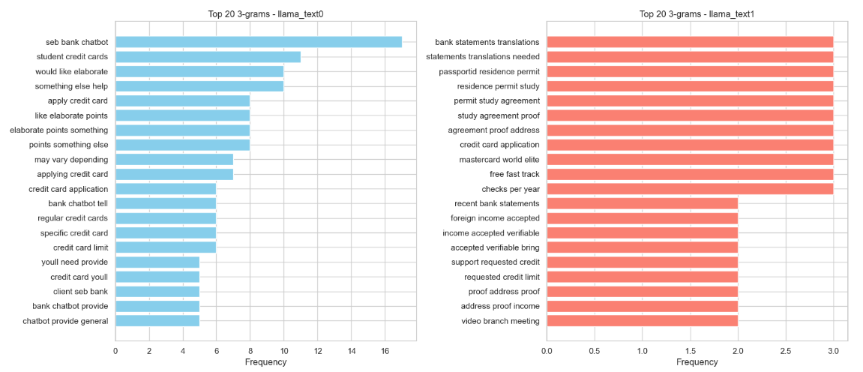
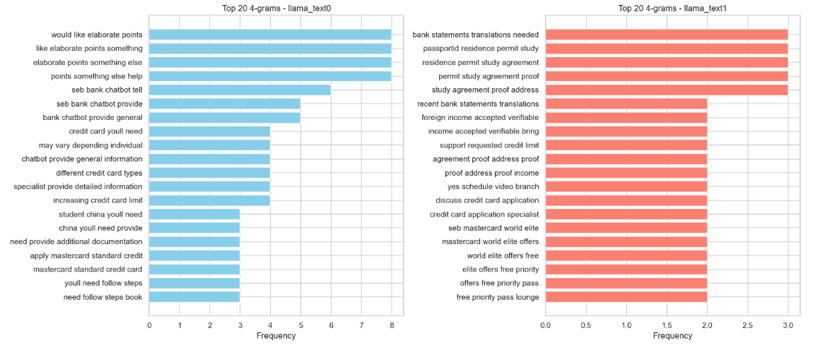
Fig.33. Top N-Gram Analyses for Llama 0 & Llama 1
For the bigram information obtained from Fig.33., it is apparent that Llama 0 could give answers in a much more polite way, as more considerate phrases are being used such as “please note”, “would like”, and “else help”. By contrast, Llama 1 gives more specific information, as indicated by highly frequently used phrases such as “online branch”, “residence permit”, “statements transactions” and “proof address”. These phrases might imply which place to submit documents and what documents to submit for credit card application. In trigram and four-gram analyses, these ideas are substantiated further. To conclude, Llama 0 offers more polite responses with more hallucination problems, whereas Llama 1 responses more concisely with more specific information for customers to take actions afterwards.
Fig.34.
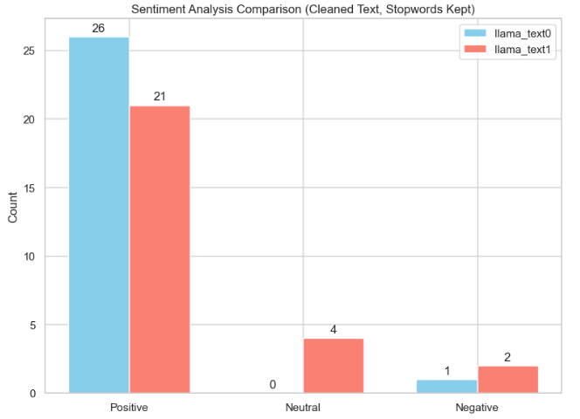
Fig.34. Sentiment Analyses for Llama 0 & Llama 1
Parallel to the findings in Fig.26. and Fig.30., from Fig.34., it is clear that when the models are switched to restricted mode, more answers with neutral tones appear. Generally, LLM-based agents tend to generate answers in a more positive tone compared to human agent 1 (Fig.18).
Fig.35.
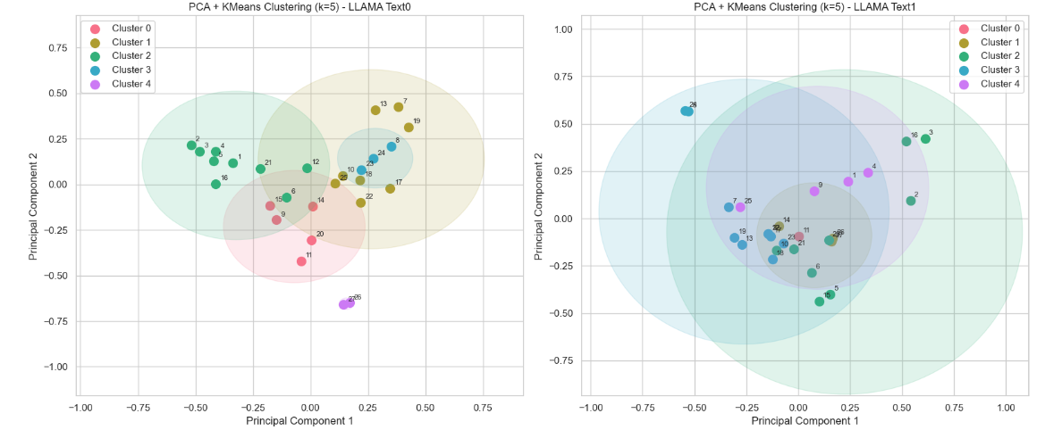
Fig.35. PCA Topic Clustering for Llama 0 & Llama 1
As with what has been observed from previous k-mean clustering models for other agents (human agents, deep 0, deep 1, gpt 0, and gpt 1), the Fig.35. still reveals the similar overlapping clusters for Llama 0 and Llama 1. Clearly when the sample size is small and there is interconnectedness between observations, the clustering result cannot be too robust.
Table 16
K-Mean Clustering Key Words Comparison for Llama 0 & Llama 1
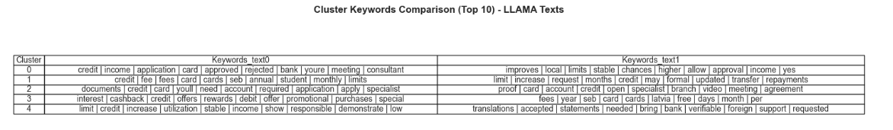
From Llama 0’s clusters, it is implied that cluster 0 is about meeting consultants for card application (“application”, “income”, “meeting”, “consultant” etc), cluster 1 is giving card fees information (“fees”, “annual”, “monthly”, “limits” etc), cluster 2 mentions documents to submit (“documents”, “required”, “apply” etc), cluster 3 indicates special offers(“offers”, “rewards”, “promotional”, “purchases” etc), and cluster 4 demonstrates how to increase credit card limit (“increase”, “credit”, “limit”, “stable”, “income” etc). The information could also be extracted from Llama 1’s clusters. Therefore, judging from k-means clustering, the research could not make conclusions about response quality between the two models (table16).
4.1.2.6 Extracted Qualitative Textual Analyses
After all the quantitative analysis above, the 4.1.2.6 section will be subjective qualitative textual analyses by using answer texts extracted from different agents. These texts will be interpreted with the theories discussed in section 2.1.
Table 17
Human Agent 1’s Partial Response Texts
No. | Customer’s Question | Human Agent 1’s Responses
1 | How can I become a client of the bank? | In chat I cannot provide you information what will be our decision.
2 | What do I need to submit are residence permit, rental agreement, personal passport? Is there anything missing? | If anything else will be needed, our specialists will inform you.  https://www.seb.lv/en/private/daily-banking/service-plans/book-meeting-time
3 | Can you provide me some basic information about the normal procedure of getting a credit card? | In chat we provide only general information about credit cards
4 | If I want to get a credit card, normally if I have a stable job with stable income in Latvia, that would be easier, right? | Cannot answer. Each case individual. Preferred income in Latvia.
5 | I am a student with part-time income from China, not Latvia, will this affect my eligibility? | Yes, it will
6 | For opening an account, what documents do I need to provide? | https://www.seb.lv/en/private/become-customer/become-customer  All the documents you mentioned before need to be provided when you attend a meeting.  Book a meeting on our homepage, choose an option to become a customer
Since among all 8 models, human agent 1 performs the worst in response accuracy (Fig.5.), answers queries in the least polite manner (Fig.7.), and includes more misinformation (Fig.2.), the author tries to understand why this is the case using the information from table 17. Based on HCI theory, if the human agent gives answers in a robotic way with fewer empathic considerations, the customers might feel disconnected and detached. For instance, in question No. 2 and No.6, human agent 1 gives link for the customer to read afterwards instead of provide specific information as requested, making the customer feel less welcoming. Similarly, ASP stresses that in customer service settings, customers need information confirmation, and more patient explanations for concerns, but human agent 1 frequently gives answers such as “cannot answer” (question No.4) and “if anything else will be needed, our specialists will inform you” (question No.2), this kind of cold responses make the author directly feel unsatisfied and disappointed. Additionally, human agent 1 constantly responds “In chat I cannot provide you information what will be our decision” and “In chat we provide only general information about credit cards”, which does not offer any meaningful information for the customer and even sabotage the customer’s positive face according to TAM and PT theory, thus weakening overall customer satisfaction and trust. More importantly, DL theory pinpoints that the warm personalized services offered by human assistants make them irreplaceable by AI, nevertheless, if the human assistant quickly gives meaningless responses to customers’ enquiries, though faster yet less satisfying.
By comparison, Deep 0 shows the best performance among all 8 agents (Fig.3), it is also interesting to explore why it surpasses others.
Table 18
Deep 0’s Partial Response Texts
No. | Customer’s Question | Deep 0’s Response (Free Mode)
1 | What should I do to increase my credit limit, say from 5000 euros to 10000 euros? | To request a significant limit increase from €5,000 to €10,000, you need to provide strong evidence of your financial capacity. Here is what you should do:  • Substantially Higher Documented Income: Prepare recent payslips or bank statements (6–12 months)  • Long Positive Repayment History: Show on-time full payments for 6–12 months.  • Upgrade Service Plan: Higher limits may require a premium card.  • Formal Request with a Specialist: Submit via SEB internet bank or book a meeting with documentation.
2 | Apart from the monthly fees, are there any other fees for different credit card types? | Yes, apart from the monthly fee, other charges apply:  • Card Issuance: €2.50–€5  • Replacement: €15–€35•  Delivery: €1 (local), €10 (abroad), €2.30 (parcel machine)  • Cash Withdrawals: Free up to €750/month at SEB/Swedbank ATMs; 2% fee (min €4)  beyond that.  • Interest: 18%/year on unpaid balances, 36%/year late interest.  • Other: €10 fee for in-person contract changes (free online).
From table 18, we could clearly notice the differences (table 17). For the two questions listed, Deep 0 first gives direct answers and then elaborate the steps for the customer to follow. After reviewing the answers, the customer could feel “being understood”, not “being rejected”. As the steps are clearly listed, the customers will know what actions to take after the conversation, thereby improving customer trust and satisfaction, which all aligns with HCI, ASC, PT and TAM theory. For instance, for question 1 “what should I do to increase my credit limit, say from 5000 euros to 10000 euros?”, after reading the answer text, the customer know that she has to provide strong financial capacity in forms of bank statements (6-12 months), service plan upgrade and the like.
Table 19
Llama 0’s Partial Response Texts
No. | Customer’s Question | Llama 0’s Response
1 | Is there any mailing fee? | As a SEB Bank chatbot, I can confirm that yes, there is a mailing fee associated with receiving certain types of credit cards or financial documents.  Examples:  • Card delivery: €5–10 fee for physical delivery.  • Statement fees: small monthly or annual charge for paper statements.  Fees vary depending on product; specialists can provide exact details when applying.
2 | Is there any special offer for first-time credit cardholders? | As a SEB Bank chatbot, I’m happy to tell you that yes, there are often special offers for first-time cardholders!  Examples:  • Sign-up bonus or cashback.  • Low introductory interest rate.  • 0 % interest on purchases.  • Exclusive rewards or travel perks.  Offers vary by card type and time; a specialist can help explain terms and conditions.

Table 20
Training Data’s Partial Response Texts (Correct Answers)
No. | Customer’s Question | Correct Answer from Training Data
1 | Is there any mailing fee for sending the card? | SEB Fees: €1 in Latvia, €10 abroad, €2.30 to a parcel machine in Latvia.
2 | Does SEB offer cardholder discounts or merchant deals? | Yes. Mastercard Standard includes travel insurance (up to 60 days), purchase protection, Mastercard Priceless discounts, Priority Pass lounge access, Fast Track security, and deals on hotels, car rentals, and dining. Mastercard Premium adds enhanced travel insurance and personalized travel services. Mastercard World Elite offers comprehensive travel insurance, extended warranty, Priority Pass & Fast Track access, luxury discounts, and special event access.
Looking at the information from Fig.3., the author notices that Llama 0 includes more hallucination problems compared to other LLM models. The responses offered by Llama 0 is the least accurate, least efficient, and least trusted although its responses enjoy a relatively higher politeness level and satisfaction level. By comparing information in table 19 with that in table 20, the author concludes that although Llama 0’s behaviours are in line with ASP and PL theories, using courteous language patterns such as “I am happy to tell you…” and “I can confirm that yes”. This might make the customer feel warm and assured. That is why although mistakes exist, customers are still more or less content. However, when meticulously matching two questions with their correct answered provided in table 20, it is evident that both answers in table 19 contains incorrect or blurry responses. For instance, the delivery fee for the credit card should range from €1 to €10, rather than €5 to €10 for question 1. For question 2, there answer to first cardholder benefits should be “No”, as SEB only offers benefits to card types with special service plan (“Standard”, “premium”, or “World Elite”) and there are no specific promotional offers specified in the training data, thus the answer for question 2 in table 19 is largely mistaken and misleading. This kind of hallucination problems make the overall performance of Llama 0 the weakest, as HCI and TAM theories inform us that the customers need direct actionable responses that are meaning, useful and helpful.
4.2 Research Reliability and Validity
In general, in any experiment-based and data-based research, reliability and validity are key criteria for guaranteeing research quality. Reliability means whether the research tools and process are consistent and replicable. That is, under similar conditions, the result should be largely the same as what has been implemented. Validity stresses whether the research could successfully measure the concept or the phenomenon under discussion. If the research design, experimental scenario, measurement dimensions are consistent and coherent with the research question, then the validity could be high.
In this research, the author takes advantage of quantitative and qualitative analyses and back up the result interpretations with textual analysis considering HCI, ASP, DL, PT and TAM theories as well to make the research statistically and theoretically well-founded.
4.2.1 Research Reliability Analyses
In order to ensure research reliability, the research makes sure that the data source is consistent, the research process is replicable, and the experiment results are verified using multi-dimensional analytical approaches.
First of all, the research training data all come from SEB official website and are used for all the models. 27 experimental questions are utilized in four categories (Information Retrieval, Comparative Queries, Promotional Queries, and Empathic Scenarios). All experiments are conducted with similar question prompts and all the LLM-based agents are required to memorize the same training data as the only answering reference. This could reduce standard error of using different training data.
Secondly, all the generated conversations, and data cleaning, and analysis python coding are available from the author’s github account publicly. In this condition, other researchers who are interested in this topic could follow the similar procedure to conduct the experiments and obtain the results as unfolded in this thesis.
Last but not the least, the study employs multiple analytical approaches, including word frequency analysis, sentiment analysis, k-mean clustering and lots of visualization tools to show the performance resemblances and discrepancies between human agents and LLM-based agents. For example, the k-mean clustering analyses for all 8 agents display resemblant overlapping plots and key words, indicating that all agents could answer in context and responses are interrelated. When one finding echoes with other findings, the research outcomes are further strengthened.
4.2.2 Research Validity Analyses
In terms of research validity, the author would mention the internal and external validity aspects in depth.
In simple terms, the research objective is to compare the differences in communication strategies and user perception of human agents and LLM-based agents in customer service setting. The research dependent variables are language features such as politeness, efficiency, and accuracy and independent variables are human agents and LLM-based agents. In the research, the customer questions, query types, and tasks are the same for all 8 agents. Additionally, both qualitative and quantitative analyses are employed. All these considerations make the final research results enjoy a relatively high validity, showing real-life differences in service performance.
Besides, the author attempts to chat with real human assistants about applying for a SEB credit card and simulate the process with 6 LLM-based agents. This problem is representative in real-life circumstances. More importantly, DeepSeek is the most widely used LLM in China, Gpt is the most widely used LLM in western countries, and Llama is the most powerful open-source LLM. By utilizing these LLMs in free response and restricted mode cases, the author could ensure that the findings will be representative to a large extent.
4.3 Limitations and Future Research
4.3.1 Limitations
Although the research is meaningful and representative, there are still some limitations that need attention for further explorations.
To begin with, there are limited data in this research (27 observations for each agent) only about credit card application issues, indicating the result could not be utilized in wider customer service situations. Furthermore, the analyses are conducted only in English conversations, implying that in multilingual scenarios, the result might be different.
Another limitation is that the training data of all the LLMs are not in public, which makes their working logic inexplicable. Moreover, as Huang et al. (2024) and other researchers stated that hallucination exists in LLMs and this phenomenon could not be eradicated (Huang et al., 2024, in press; Darwish, Rashed, & Khoriba, 2025), the author could not give a solution to fully resolve the issue in this research as well, and the research is only able to pinpoint that with more restrictions, LLMs might generate fewer made-up misleading responses.
More importantly, the author has utilized lots of theoretical foundations and analytical approaches to validate the findings, but some linguistic and semantic explanations still include some subjective judgements such as how to evaluate politeness level and trust level in Likert Scale.
4.3.2 Future Research
With all the limitations discussed thoroughly in section 4.3, in this section, the research will clarify what improvements and further research could be implemented to make the results even more robust.
Above all, the research could involve more participants to conduct experimental chatting experiences in real-life scenarios and multilingual materials can be considered as well. More questions in diverse types could be included in the empirical studies. What is more, human and AI mixed customer service systems can also be considered to find the best cooperation strategy in offering customer services. Finally, apart from financial banking customer service sector, other business domains such as rental car services and such can also be taken into account to obtain generalized outcomes.

5. Conclusion
In the final stage, the author would like to make conclusions about all the research conducted in this thesis.
5.1 Research Overview
From digital humanities’ perspective, the research focuses on the communication discrepancies between human agents and LLM-based agents in customer service setting. In the comparative research, the author chooses 2 human agents and 3 LLM-based agents (gpt-oss:120b, DeepSeek (web), and llama3:8b). All the agents will function as a chatbot to answer the customer (the author)’s queries based on memorized data collected from SEB official website. All the LLM-based agents will interact with the customer in Mode 0 (free response mode) and Mode 1 (restricted mode). The interaction texts and Likert Scale data will be input in data.xlsm excel file for further analyses. After in-depth multi-dimensional qualitative and quantitative analyses including descriptive statistical tables, various comparative visualization plots, partial correlation networks and regression analyses, word frequency, sentiment, n-gram, k-mean clustering and textual analyses using HCI, ASP, TAM, DL theories.
In conclusion, the overall findings are as follows:
First, Gpt and DeepSeek models excel in response accuracy, consistency and efficiency. The clearly structured answers with constructive actionable steps make them perfect substitutes for human agents in customer service field. This indicates LLM-based agent has great potential to serve as customer service chatbots.
Second, human agents could surpass LLM-based agents in response politeness and naturalness. Especially, in the research, human agent 2 could offer empathy when the customer is concerned about eligibility and give accurate information based on professionalism and expertise. For example, when the customer asks about the expiration date of SEB credit card, human agent 2 could answer directly and concisely with short sentence: “the credit card is valid for 4 years”. As human assistants could understand HCI, ASP, TAM and other related theories thoroughly and make the most of them in interaction process, which could ensure higher customer trust and satisfaction. Although one important factor that can not be ignored is that human agents’ performances could vary greatly due to personal attitude, experience level and typing speed.
Thirdly, Llama 0 performed the worst among all the agents, as it produces lots of made-up answers not included in the training data provided. This kind of hallucination problems can be mitigated in restricted mode when all the LLM-based agents are requested to respond in a more concise way with only information memorized from the training data.
In summary, LLM-based agents could outperform human agents in response accuracy, politeness, and efficiency in most cases, except for the poor performance level of Llama 0, whereas human agents could answer more naturally with more specific answers to certain queries in a more humanized manner. Additionally, LLM-based agents should make improvements by integrating TAM, PT and HCI theory frameworks and offer more humanlike responses, giving more pleasant customer service experiences. Likewise, human agents should receive proper training to offer more consistent and professional responses to meet customers’ demands effectively and efficiently.
5.2 Research Validity and Reliability
As explained in section 4.2, the research is based on real-life data collection, all empirical questions are set in the same scenario with each agent, making sure the data obtained are comparable. Moreover, the research harnesses multi-dimensional qualitative, textual and quantitative analyses to receive coherent consistency in findings. Furthermore, the research design framework can be replicable are is verified with diverse methods. Therefore, it is validated and trustworthy.
5.3 Research Question and Hypothesis Validation
With regard to the research question “What are the differences in chatbots compared to human agents when conducting customer service routines?” The research shows that human agents could respond more naturally with personal touch, but their personal attitudes and expertise could vary, which could result in inconsistent customer service quality among different human assistants. However, AI chatbots could offer more accurate and consistent responses more efficiently, but the polite tone could be robotic and mechanic. Without clear instructions and restrictions, the LLM-based agents could exhibit hallucination behaviours.
In terms of “how differences in the style and features of interaction between chatbots and customers may affect the level of trust and acceptance of clients”, for all the LLM-based agents tested in this research, it appears that when the agent could offer accurate answers in a polite, efficient manner, customers tend to have higher level of trust and satisfaction of using it.
As for “How hallucination limits the application of these chatbots and how they would affect business and customers in a whole”, the research displays that when LLM-based agents are given fewer restrictions, they might offer random made-up mistaken information as illustrated in the case of Llama 0. Thus, it is better to training the model, test the model, and adjust the model before taking into serious practice.
Considering the five hypotheses put forward in section 2.5:
H1 LLM-based agents will underperform human agents in response accuracy.
Based on findings in 4.1.1.4 section (Fig.5.), H1 is largely disproved, because for all 8 agents, most LLM-based agents could offer relatively more accurate answers compared to human agents, except for Llama 0, which performs slightly better than human agent 1 in response accuracy.
H2 LLM-based agents will outperform human agents in response efficiency.
According to Fig.6., H2 is largely validated since only Llama 0 responds queries with over 2 minutes for each, all other LLM-based agents could respond with averagely higher efficiency score (over 4.0). Although human agent 1 gives answers in a fast pace (5.0), not so effective and meaningful answers are given to meet the customer’s demands.
H3 LLM-based agents can show higher level of politeness compared to human agents.
H3 is fully verified because human assistants’ politeness levels differ greatly, but all 8 LLM-based agents could generate answers with an average politeness score of over 3.5 (Fig.7.).
H4 Customer Trust is highly linked to the influence of response accuracy and politeness.
H4 is not validated in table 9 in human agent 1’s case, but partially affirmed in Fig.12 for human agent 2’ case, indicating customer trust level for human agents can vary greatly. However, when all 8 agents are considered, H4 is largely authenticated (Fig.14.), since it is reasonable for customers to trust LLM-based agents when they keep producing more accurate responses in a faster pace.
H5 The Overall Customer Satisfaction and Acceptance will be dependent on system quality, information quality and response efficiency.
H5 is partially correct (Fig.10.) for human agent 1, largely incorrect (Fig.13.) for human agent 2, and is greatly substantiated when all 8 agents are taking into account (Fig.15.).
To conclude, except that H1 is disproved, all other hypotheses are largely validated in this thesis, showing that LLM-based agents could have great potential in customer service chatbot area.
5.4 Discussion
Academically speaking, in the future, other researchers could explore much broader topics related to LLM communication logic and trust system building. In this way, LLM-based chatbots could be more adaptable to diverse fields in different scenarios in a more consistent and stable way. In practice, when enterprises consider using LLM-based chatbots, it is necessary to consider how to make human assistants and chatbots work together, thereby improving service quality and boosting company reputation. As a digital humanist, in future studies, the author intends to take advantage of the digital literacy (NLP analyses, text analysis etc) to conduct more in-depth comprehensive researches and attempts to put theory into practice soon.

List of References
Accenture. (2024, June 27). Accelerating reinvention to support growth with AI-powered operations. Accenture. https://www.accenture.com/us-en/insights/strategic-managed-services/reinvent-operations-with-genai
Acemoglu, D., & Restrepo, P. (2020). Unpacking skill bias: Automation and new tasks. AEA Papers and Proceedings, 110, 356–361. https://doi.org/10.1257/pandp.20201063
Ali, M. S. I. (2025, June 12). Chatbots vs human agents: A comparative study of customer satisfaction in the financial services industry in Sri Lanka [Preprint]. SSRN. https://doi.org/10.2139/ssrn.5292006
Autor, D. H. (2019). Work of the past, work of the future. AEA Papers and Proceedings, 109, 1–32. https://doi.org/10.1257/pandp.20191110
Azevedo, A., Marques da Silva, S., & Caramelo, J. (2021). Vocational education and training research in Portugal: “Industry 4.0” & education. In EERA ECER 2021: Education and transitions [Conference presentation]. European Educational Research Association. https://eera-ecer.de/ecer-programmes/conference/26/contribution/50675
Brown, P., & Levinson, S. C. (1987). Politeness: Some universals in language usage. Cambridge University Press.
Berry, D. M. (2023). The limits of computation: Joseph Weizenbaum and the ELIZA chatbot. Weizenbaum Journal of the Digital Society, 3(3). https://doi.org/10.34669/WI.WJDS/3.3.2
Biswas, S., Carson, B., Chung, V., Singh, S., & Thomas, R. (2020, September). AI-bank of the future: Can banks meet the AI challenge? McKinsey & Company. https://www.mckinsey.com/industries/financial-services/our-insights/ai-bank-of-the-future-can-banks-meet-the-ai-challenge
Castelo, N., Boegershausen, J., Hildebrand, C., & Henkel, A. P. (2023). Understanding and improving consumer reactions to service bots. Journal of Consumer Research, 50(4), 848–863. https://doi.org/10.1093/jcr/ucad023
Chandrakala, C. B., Bhardwaj, R., & Pujari, C. (2024). An intent recognition pipeline for conversational AI. International Journal of Information Technology, 16, 731–743. https://doi.org/10.1007/s41870-023-01642-8
Darwish, A. M., Rashed, E. A., & Khoriba, G. (2025). Mitigating LLM hallucinations using a multi-agent framework. Information, 16(7), 517. https://doi.org/10.3390/info16070517
Davis, F. D. (1985). A technology acceptance model for empirically testing new end-user information systems: Theory and results (PhD thesis). Massachusetts Institute of Technology.
Davis, F. D. (1989). Perceived usefulness, perceived ease of use, and user acceptance of information technology. MIS Quarterly, 13(3), 319–340. https://doi.org/10.2307/249008
Euart, J., Ferreira, N., Martinez Arroyo, J., Niza, G., & Snezhkova, N. (2020a, July 1). Financial decision-maker sentiment: France. McKinsey & Company. https://www.mckinsey.com/industries/financial-services/our-insights/financial-decision-maker-sentiment-france
Euart, J., Ferreira, N., Gordon, J., Gupta, A., & Hilal, A. (2020b, July 23). Financial life during the COVID-19 pandemic — an update. McKinsey & Company. https://www.mckinsey.com/industries/financial-services/our-insights/a-global-view-of-financial-life-during-covid-19
Gulati, S., McDonagh, J., Sousa, S., & Lamas, D. (2024). Trust models and theories in human–computer interaction: A systematic literature review of 47 studies. Computers in Human Behavior Reports, 16, Article 100495. https://doi.org/10.1016/j.chbr.2024.100495
Haugeland, I. K. F., Følstad, A., Taylor, C., & Bjørkli, C. A. (2022). Understanding the user experience of customer service chatbots: An experimental study of chatbot interaction design. International Journal of Human-Computer Studies, 158, 102788. https://doi.org/10.1016/j.ijhcs.2022.102788
Huang, L., Yu, W., Ma, W., Zhong, W., Feng, Z., Wang, H., Chen, Q., Peng, W., Feng, X., Qin, B., & Liu, T. (2024, in press). A survey on hallucination in large language models: Principles, taxonomy, challenges, and open questions. ACM Transactions on Information Systems (TOIS). https://doi.org/10.1145/3703155
Holthöwer, J., Mende, M., Scott, M. L., Lunardo, R., & Grewal, D. (2022). Robots do not judge: Service robots can alleviate embarrassment in service encounters. Journal of the Academy of Marketing Science, 51(2), 1–18. https://doi.org/10.1007/s11747-022-00862-x
Ji, Z., Lee, N., Frieske, R., Yu, T., Su, D., Xu, Y., Ishii, E., Bang, Y. J., Madotto, A., & Fung, P. (2023). Survey of hallucination in natural language generation. ACM Computing Surveys, 55(12), 1–38. https://doi.org/10.1145/3571730
Jurafsky, D., & Martin, J. H. (2009). Speech and language processing: An introduction to natural language processing, computational linguistics, and speech recognition (2nd ed.). Pearson Prentice Hall.
Kaakandikar, R., Thombare, R. B., Nikam, S. S., Karamore, V. M., & Wadmare, S. B. (2025). Study of Customer Perception of AI-Driven Chatbots in Banking Services. Advances in Consumer Research, 2(2), 693-703.
Kaewkitipong, L., Chen, C., Han, J., & Ractham, P. (2022). Human–Computer Interaction (HCI) and Trust Factors for the Continuance Intention of Mobile Payment Services. Sustainability, 14(21), 14546. https://doi.org/10.3390/su142114546
Kagermann, H., Wahlster, W., & Helbig, J. (2013). Recommendations for implementing the strategic initiative Industrie 4.0: Final report of the Industrie 4.0 working group [Report]. acatech, National Academy of Science and Engineering. https://en.acatech.de/publication/recommendations-for-implementing-the-strategic-initiative-industrie-4-0-final-report-of-the-industrie-4-0-working-group/
Karanikolas, N. N., Manga, E., Samaridi, N., Stergiopoulos, V., Tousidou, E., & Vassilakopoulos, M. (2025). Strengths and weaknesses of LLM-based and rule-based NLP technologies and their potential synergies. Electronics, 14(15), 3064. https://doi.org/10.3390/electronics14153064
Kuligowska, K. (2015). Commercial chatbot: Performance evaluation, usability metrics and quality standards of embodied conversational agents (2nd ed.). Professionals Center for Business Research. https://ssrn.com/abstract=2569637
Lim, S., Susastra, A. C., Roberts, C., & Yusramdaleni, R. (2020). The analysis of customer satisfaction factors which influence chatbot acceptance in Indonesia. Management Science Letters, 10(6), 1225–1232. https://doi.org/10.5267/j.msl.2019.11.036
Ltifi, M. (2023). Trust in the chatbot: A semi-human relationship. Future Business Journal, 9(1), Article 88. https://doi.org/10.1186/s43093-023-00288-z
Minaee, S., Mikolov, T., Nikzad, N., Chenaghlu, M., Socher, R., Amatriain, X., & Gao, J. (2024). Large language models: A survey. arXiv. https://doi.org/10.48550/arXiv.2402.06196
Munn, L. (2023). Digital labor, platforms, and AI. In M. Broy, G. Holzinger, M. Tscheligi, & C. Wagner (Eds.), Introduction to Digital Humanism (pp. 557–569). Springer. https://doi.org/10.1007/978-3-031-45304-5_35
Nass, C., & Moon, Y. (2000 [online 2002]). Machines and mindlessness: Social responses to computers. Journal of Social Issues, 56(1), 81–103. https://doi.org/10.1111/0022-4537.00153
Patil, R., & Gudivada, V. (2024). A review of current trends, techniques, and challenges in large language models (LLMs). Applied Sciences, 14(5), 2074. https://doi.org/10.3390/app14052074
Patra, B., & Kumar, M. (2020). Natural language processing in chatbots: A review. Turkish Journal of Computer and Mathematics Education (TURCOMAT), 11(3), 2890-2894. https://doi.org/10.61841/turcomat.v11i3.14655
Sanny, L., Susastra, A. C., Roberts, C., & Yusramdalen, R. (2020). The analysis of customer satisfaction factors which influence chatbot acceptance in Indonesia. Management Science Letters, 10(3), 555–564. https://doi.org/10.5267/j.msl.2019.11.036
Shahbandi, M. (2025). AI chatbots vs. human customer service: Impact on consumer satisfaction and purchase decisions. International Business & Economics Studies, 7(3), 36. https://doi.org/10.22158/ibes.v7n3p36
Singla, A., Sukharevsky, A., Yee, L., Chui, M., & Hall, B. (2025, March). The state of AI: How organizations are rewiring to capture value. SITIC. Retrieved November 8, 2025, from https://sitic.org/the-state-of-ai-how-organizations-are-rewiring-to-capture-value/
Singh, H. (2021, October 5). AI-powered chatbots transforming customer support through personalized and automated interactions. SSRN. https://doi.org/10.2139/ssrn.5267858
Van Doorn, J., Mende, M., Noble, S. M., & Hulland, J. (2016). Domo arigato Mr. Roboto: Emergence of automated social presence in organizational frontlines and customers’ service experiences. Journal of Service Research, 20(1), 43–58. https://doi.org/10.1177/1094670516679272
Van Deemter, K. (2024). The pitfalls of defining hallucination. Computational Linguistics, 50(2), 807–816. https://doi.org/10.1162/coli_a_00509
Wikipedia. (2025). Face (sociological concept). https://en.wikipedia.org/wiki/Face_(sociological_concept)#Chinese
Wulf, J., & Meierhofer, J. (2024). Utilizing large language models for automating technical customer support. Zurich University of Applied Sciences & Data Innovation Alliance. https://doi.org/10.48550/arXiv.2406.01407
Xu, Z., Jain, S., & Kankanhalli, M. (2024). Hallucination is inevitable: An innate limitation of large language models [Preprint]. arXiv. https://doi.org/10.48550/arXiv.2401.11817
Zhang, Y., Li, Y., Cui, L., Cai, D., Liu, L., Fu, T., Huang, X., Zhao, E., Zhang, Y., Chen, Y., Wang, L., Luu, A. T., Bi, W., Shi, F., & Shi, S. (2023). Siren’s song in the AI ocean: A survey on hallucination in large language models. arXiv preprint arXiv:2309.01219. https://arxiv.org/abs/2309.01219
Pan, Z. (2025). Supplementary materials for the master’s thesis “AI Chatbots in Business Customer Service: A Comparative Study of LLM-based and Human Agents from a Digital Humanities Perspective” [Source code]. GitHub. https://github.com/Grace128pan/Thesis

Failure to meet the deadlines may result in the student not being admitted to pre-defend and defend the Master Thesis.

